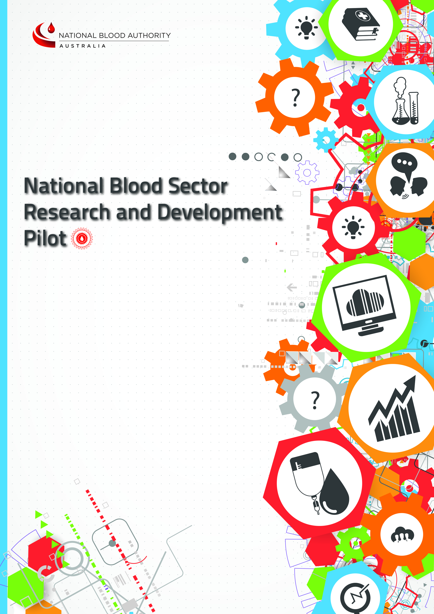
>
CLOSING DATE AND TIME:
10am, 8 April 2016
Australian Eastern Standard Time (AEST)
Grant Funding Application for
Project grants and Seed grants
INSTRUCTIONS TO APPLICANTS

Before completing this Grant Funding Application, please consult the National Blood Sector Research and Development Pilot Project, Information for Applicants Booklet available at: www.blood.gov.au

Submitting the APPLICATION

Closing Time: 10am 8 April, 2016 (Australian Eastern Standard Time)

Applicants’ responses must be lodged electronically before the Closing Time and in accordance with the response lodgement procedures set out in the Information for Applicants booklet.

Applicants lodged wholly or partly after the Closing Time will be deemed to be late. A late Application will not be admitted to the assessment process unless it is shown that the lateness was due solely to mishandling of the Application by the National Blood Authority (NBA).

Applicants are to direct all queries about this application form to:
- Attention: Project Director
- Email: R&D@blood.gov.au

Completing the APPLICATION Form

All Project and Seed grant applications must be submitted using this form. All sections of this form and attachments must conform to the following:
- Applications must be completed in English
- All costings must be in Australian dollars (GST Exclusive)
- Left and right margins of at least 2cm
- Font no smaller than 11 point (preferred font is Arial)
- Line spacing of 1.0
- Maximum character and word limitations
- Responses must be completely self-contained. No hyperlinked material may be incorporated by reference, noting that any such links will be ignored.
- The certification must be substantially in the form at page 15 of this application (Application Certification), which is to be signed by duly authorised persons. Applicants should not change the text of the Certification.

SECTION A - TYPE OF GRANT

What type of grant are you applying for:
Project grant
Seed grant

SECTION B – OVERVIEW
Principal Chief Investigator (Applicant):
Administering Institution (which will receive funds from the National Blood Authority):
Simplified Project title:  The Simplified Project Title should be in lay terminology and be suitable for release to the media or for general publication. Avoid the use of technical terms and abbreviations. | (100 characters max)
Scientific Project title:  The Scientific Title should accurately describe the nature of the project being undertaken. | (300 characters max)
Project summary (500 words):
Using lay terminology summarise your research questions and proposed methods. Outline the potential benefits to either:
- Efficient and effective use of immunoglobulin products; or
- Patient Blood Management evidence gaps.
Describe how the project will be translated into practice change that will directly impact on individual patients’ outcomes, population health and wellbeing and/or blood or blood product use.
Your answer should be suitable for release to media and inclusion on the NBA website.
Describe where the project will be conducted (100 words):
Total amount requested, Excluding GST

Total time required to complete project (can be up to 36 months for Project grants and 12 months for Seed grants noting that all Round 1 projects must be completed by 31 December 2019):
Funding currently being received from any other funding body and/or submissions planned or under consideration by any other funding source/s for this project:
List the name of the funding agency(s), expected date of notification of success and the amount(s) received and/or requested.
Include applications already submitted and planned submissions

Contact Officer for the purposes of the Grant Application

Full Name:
Position:
Organisation:
Contact phone number:
Email:
Fax:
Postal address:

SECTION C – EVALUATION CRITERIA

This section sets out the evaluation criteria that will be utilised to assess value for money. Applicants should note that the evaluation criteria are not listed in any order of importance.

Mandatory requirements

Applications will be assessed as to whether they meet the minimum content and formatting requirements (see Completing the Application, page 1).

Evaluation Criteria

Applications will also be assessed on the basis of the following evaluation criteria:

    - Research scope, focus and potential value
    - Quality
    - Governance and Ethics
    - Efficient and Effective use of funds

Each application will be given an overall rating regarding the degree of confidence that the proposal will deliver value for money.

Evaluation Criterion 1 – Research Scope, Focus and Potential Value

Describe why this research is a priority. Outline the scientific background to the application, critically evaluate existing knowledge, and identify the gaps in knowledge that address the following priority areas for this pilot project: (1000 words max)
- Efficient and effective use of immunoglobulin products; or
- Patient Blood Management evidence gaps.

What is the research question? (100 words)

State the hypotheses to be tested, the project aim and the scientific objectives of the project (200 words)

Will there be an economic evaluation or costing component? If so, provide details. (200 words)

What new or relevant evidence will the research project generate for policy and/or practice? What are the likely impacts of the results of the project on either: efficient and effective use of immunoglobulin products; or Patient Blood Management research gaps. (300 words)

What is the potential of the project to impact policy and/or practice? Comment on the extent to which anticipated outcomes from the research can be generalised, scaled, translated or embedded into practice. (300 words)

Indicate the start and end dates for the project.
Proposed start date: | Nominated end date:

Evaluation Criterion 2 – Quality

Administering Institution

Indicate whether the institution responsible for administering the grant funds, is registered under the NHMRC Administering Institution Policy, March 2015.
Yes No

Participating institutions

List the actual institutions and departments where the research will be carried out and identify the proportion of research effort for each institution. The total research effort should sum to 100%.
Institution | Department | Percentage of research effort
Please add additional rows and complete details for any additional participating institutions

Confirm that letters of support for this research project have been obtained from all participating institutions named in this application above. Provide a copy of each letter with your application. If you are unable to provide a copy of any letter of support please provide reasons for this.
Yes No

Research Design and Methods

Describe the approach to the research. (2000 words)

Address in detail the design and methods of the proposed project. Make clear how they will test the hypotheses and achieve the aims of the project. Specify the data that will be collected and how they will be collected, analysed and interpreted. Describe and justify any new methods to be developed in terms of their advantages relative to existing methods. Identify potential difficulties and limitations of the proposed procedures, and alternative approaches that might be used to achieve the aims.
References: A list of all references cited must be provided. Exclude references from the word count.

Provide the key project milestones and timelines. These will form part of the reporting requirements to be incorporated into the grant Funding Agreement for successful applicants. (500 words)

Research Team

Principal Chief Investigator details
The Principal Chief Investigator (Applicant) must be employed by the Administering Institution.
Full Name:
Position:
Organisation:
Contact phone number:
Email:
Postal address:

Outline the role of the Principal Chief Investigator in the proposed project. (100 words)

Identify the residency status of the Principal Chief Investigator and attach evidence of Australia Citizenship (Birth Certificate or Passport), Permanent Residency or evidence of submission for Permanent Residency. Identify below the type of actual evidence being attached.
Australian Citizen Permanent Resident Applicant for Permanent Residency

Will the Principal Chief Investigator be based in Australia during the whole period the research is to be conducted? If No, for what period will he/she be absent from Australia and what arrangements will be put in place to ensure continuous project leadership.
Yes No

Other Chief Investigator(s)
If there is to be more than one Chief Investigator provide in the table below justification for why each Chief Investigator is needed, including the specific expertise and experience that each brings to the project.
# | Full Name | Position | Organisation | Contribution
1
2
3

Associate Investigator(s)
Include other proposed investigators in the table below.
# | Full Name | Position | Organisation | Contribution
1
2
3
4
5
6
7
8
9
10

Other Team Members
Include in the table below any other proposed team members for whom grant funding is sought.
# | Full Name | Position | Organisation | Contribution
1
2
3
4
5
6
7
8
9
10

Biographies
Please attach a brief biography (no more than two pages) for each member of the research team for whom funding is sought. If the position is currently not filled, include a job description. Note that funding will not be provided for associate investigators. The biographies should focus on the member’s achievements, track record, training and skills which will be considered for the explicit value that the expertise brings. In addition to the biography, you may include a list of relevant publications, presentations, grants and awards.

Confirm that all other CIs, AIs and other researcher team members named in this application have agreed to be named within the application and have endorsed the application. If unable to confirm please provide reasons for this.
Yes No

Essential Partners and Stakeholders

Include in the table below any other proposed partners for whom no grant funding is sought but their contribution is required for the successful conduct of the project. Identify relevant stakeholders who have or will be engaged in the development of the proposal and during the research (e.g. clinicians, consumers, health service management, researchers, patient groups, policy makers).
Partners and Stakeholders:  List essential partners and stakeholders required for successful conduct of the project | Name/Group | Position (where relevant) | Organisation | Contribution to project

Confirm that all Essential Partners and Stakeholders named in this application have agreed to be named within the application and have endorsed the application. If unable to confirm please provide reasons for this.

Yes No

Evaluation Criterion 3 – Governance and Ethics

Governance structure

Provide a description of the governance structure for the project. Describe how the participating institution(s) will approve, monitor and interact with the project. Indicate if there are any collaborative aims. (500 words max)

Confirm that the research will be conducted in accordance with the Australian Code for the Responsible Conduct of Research 2007.
Yes No

Confirm that the research will be conducted in accordance with the National Statement on ethical conduct in human research, 2007 (updated May 2015).
Yes No

Describe all approvals that will be required before the research project can proceed, i.e. ethics and governance approvals. State the status of each approval. (200 words)

Does the research project require access to data held by the NBA? If yes, confirm the project can abide by the requirements of the NBA’s Data Governance Framework. http://www.blood.gov.au/data-governance

Is the Applicant agreeable to all the terms and conditions set out in the draft Grant Funding Agreement in the Information for Applicants booklet. The Applicant should indicate ‘agreement to all terms and conditions’ or, ‘partial agreement to the terms and conditions’ of the draft Grant Funding Agreement.

If the Applicant partially agrees or does not agree to any term or condition in the draft Grant Funding Agreement, the Applicant should list the clause number, the reasons for partial or non-compliance, and any proposed modification to those clauses.
Agreement to all terms and conditions Partial agreement to the terms and conditions

Is the Applicant agreeable to the minimum reporting requirements as outlined in the Information for Applicants booklet noting that project specific, content, format and timeframes for reporting will be advised as a part of the Grant Funding Agreement.
Yes No
If no, please provide details of an alternative reporting framework.

Has the Applicant informed (or is the Applicant agreeable to informing) all funded members of the research project, that their participation in the research project may be publicly disclosed should the project be awarded a grant.
Yes No
If no, please provide arguments to justify any proposal for this information to be kept confidential

If your application is successful, please indicate whether you provide your approval for the NBA to publish the following minimum information on its website:
- Research Aim
- Recipient(s)
- Administering Institution
- Value
- Approval Date
- Grant term (months)
- Grant funding location (city)
Approve Do Not Approve
If you do not approve, please provide arguments to justify any proposal for this information to be kept confidential

Please indicate your commitment or intentions with respect to publication of the results of your research.

If your project is a trial, please indicate your intentions with respect to registering your trial on a publicly available register including naming the register.

Evaluation Criterion 4 – Efficient and Effective use of Funds

Funding requested

The NBA has made available up to $400,000 per year per grant round. The total amount, of $400,000 per annum per grant round, will be divided between the successful grant applicants.

Project budgets must be expended within the three year funding timeframe. Funding may be used for costs associated with the research project but cannot be directed towards capital works, general maintenance costs, telephone/communication systems, basic office equipment such as desks and chairs, rent and the cost of utilities. While project grants are available for up to 3 years, seed grants are only available for up to one year. However, seed grant funding may be requested for Year 1, Year 2 or Year 3 of the funding round.

Research Members’ Salary Support Costs:

List in the table below whatever salary you deem appropriate for grant-supported personnel.

Provide the name if known, proposed level of appointment (e.g. Chief Investigator/Research Assistant), the annual fraction of full-time for the appointment, the annual full-time equivalent salary level, and the amount requested. Biographies (or a job description if the position is not filled) must be supplied for all research team members for whom funding is requested.

Name  Only if a research member is also an investigator, identify him/her by name. | Level of appointment.  Chief Investigator/ Research Assistant etc | Full-time equivalent salary in $ (excl GST) | Annual fraction of full-time for the appointment.  Example 0.5 EFT |  |  | Funding requested (excl. GST)
 |  |  | Year 1  (20XX) | Year 2  (20XX) | Year 3  (20XX) | Year 1  (20XX) | Year 2  (20XX) | Year 3  (20XX)
TOTAL
All costs other than salaries:
Equipment: Specify individually all items of equipment that cost more than $5000 and attach three written quotes in support, or provide a reason why three quotes were not able to be obtained.

Maintenance and consumable items: Itemise in readily understood terms such as interviews, travel costs, laboratory animals, reagents, etc.

Budget Item  e.g. travel, advertising, equipment, venue hire for workshops. | Funding requested (excl. GST) |  |  | Description  (<100 words per item)
 | Year 1  (20XX) | Year 2  (20XX) | Year 3  (20XX)
TOTAL

Cash and in-kind contributions

Support from institutions and others: Describe in the table below existing resources and infrastructure critical to the proposed project’s success, with a view to reassuring assessors of the research project’s feasibility. For in-kind contributions, specify ‘In-kind’ in the funding columns and include the estimated/actual monetary value of the contribution.

Source  Administering Institution and partner organisations | Budget item | Funding (excl. GST) or in-kind# |  |  | Description  (<100 words per item)
 |  | Year 1  (20XX) | Year 2  (20XX) | Year 3  (20XX)
 | TOTAL

Other Grant Funding sources

Current Grant Funding: List in the table below all funding currently being received from any other funding body for this research project.

Funding body | Amount | Funding period | Description. (<100 words per item)
TOTAL

Current Grant Funding Applications and/or planned Grant Funding Applications: List in the table below all funding applications planned or under consideration by any other funding sources for this research project.

Funding body | Amount requested and/or planned to request | Funding period | Description. (<100 words per item)
TOTAL

CERTIFICATION BY APPLICANT AND THE ADMINISTERING INSTITUTION HEAD OF DEPARTMENT/CHIEF EXECUTIVE
Applicant
I certify that all details provided in the application (including attachments) are correct and that I have read, understood, and have abided by the instructions associated with this form. I agree to carry out the project in accordance with the principles of the Australian Code for the Responsible Conduct of Research (2007), (under review at time of releasing this Application, – February 2016) . http://www.nhmrc.gov.au/guidelines-publications/r39, and the National Statement on ethical conduct in human research, 2007 (updated May 2015) http://www.nhmrc.gov.au/guidelines-publications/e72

I acknowledge that all ethics approvals and clearances necessary to complete my project as outlined in this application must be in place before commencement of the work and that the National Blood Authority will not release funds until such time as a copy of all such approvals and clearances have been received.
By signing, I confirm that I have complied with all instructions in the application form and understand that failure to do so may result in the withdrawal of the application from the assessment process.
All funds awarded to the Administering Institution as part of the National Blood Sector Research and Development grant pilot project will be used only for the purpose for which they were awarded.
Applicant (full name): |  | Date:
Signature: |  | __/__/2016

Chief Executive/Head of Department
I certify that appropriate facilities and in-kind support will be available to the Applicant if successful and that I am prepared to have the project carried out in accordance with the Australian Code for the Responsible Conduct of Research (2007).
Title: |  | First Name: |  | Surname:
Email: |  |  |  | Telephone:
Department/Institution: |  |  |  |  |  | Date:
Signature: |  |  |  |  |  | __/__/2016

If this certification is not signed by the Department Head/Chief Executive of the Administering Institution, the Application is not valid.

