User Approval Process by Facility Administrator

Purpose

This Tip Sheet is designed for facility administrators to understand how to approve requests for access to your
BloodNet facility so that users can access their site in BloodNet.

Pre-requisite
Facility administrators must have already created their own BloodPortal account at http://portal.blood.gov.au, have requested access to BloodNet and been approved by another facility administrator (or the NBA if you are the first facility administrator to apply at your site). Please refer to the Registering for an individual login to BloodNet Tip Sheet if you have not already created your account.

Step 1

Navigate in a web browser to https://portal.blood.gov.au and login using the username and password you have previously created.

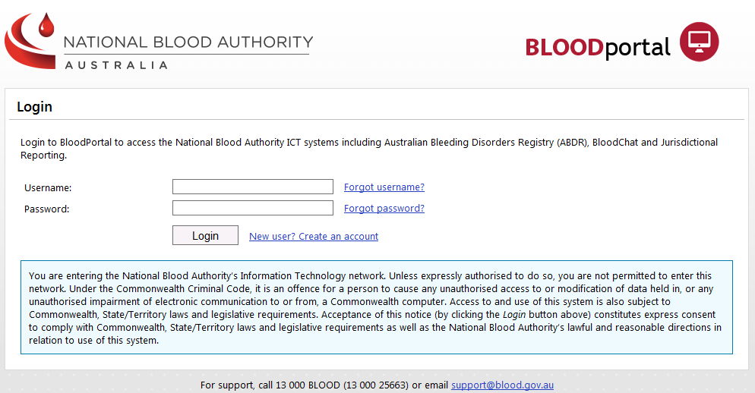

Step 2

Click on the BloodNet Application link:

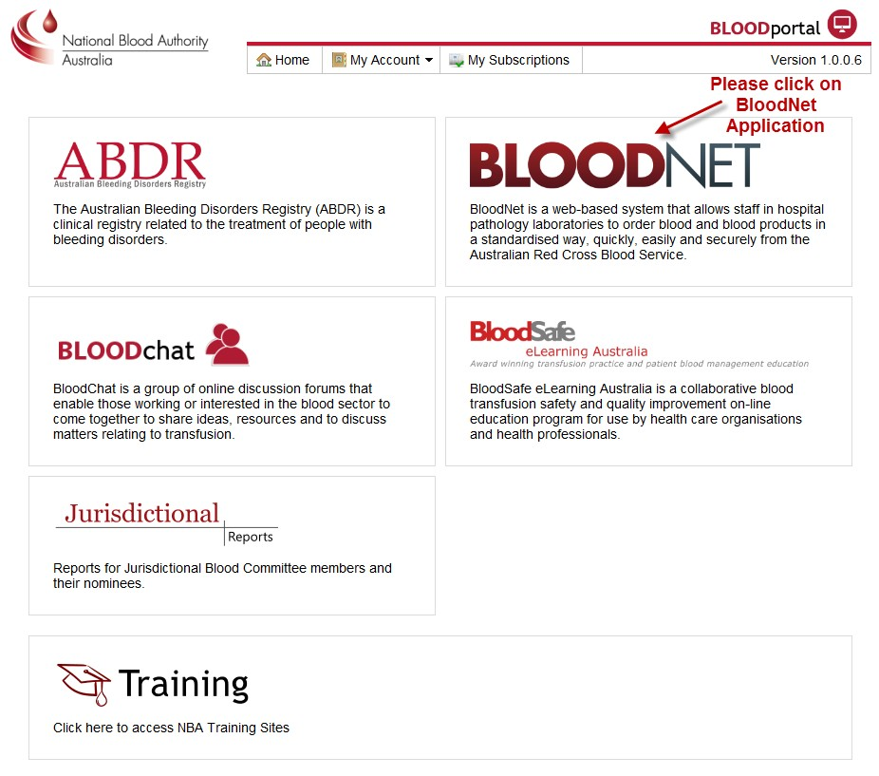

Step 3

Click on the Access Request link in the top right hand corner and it will direct you to the page shown below. This screen will display a list of all users who have requested access to the BloodNet sites that you are a facility administrator for. Please click the Action link as indicated by the red circle below to view the request details. You can also Filter Access Requests by using the drop down menus to filter requests by pending, approved or rejected as required. Each page only displays 10 records at a time so check for additional pages to ensure no requests have been left out.

