5

Registering and Requesting Access to BloodNet

Purpose

This Tip Sheet is designed for people who access BloodNet at their Facility and therefore need to create an individual login to the BloodPortal to enable them to continue accessing BloodNet after 19 January 2013. Individual logins are essential for BloodNet to enable an appropriate audit trail to be developed to identify which officers undertook which actions – a crucial step on the path to BloodNet and Laboratory Information System (LIS) interfaces.

Step 1

Navigate in a web browser to https://portal.blood.gov.au and click on New User? Create An Account as highlighted by the red arrow below.

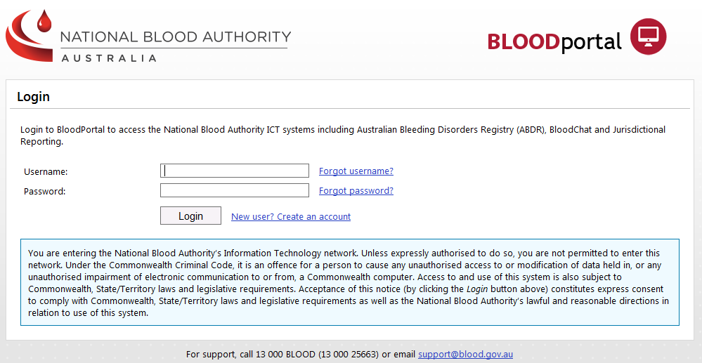

This will take you to the registration page shown below to be able to create a new BloodPortal account

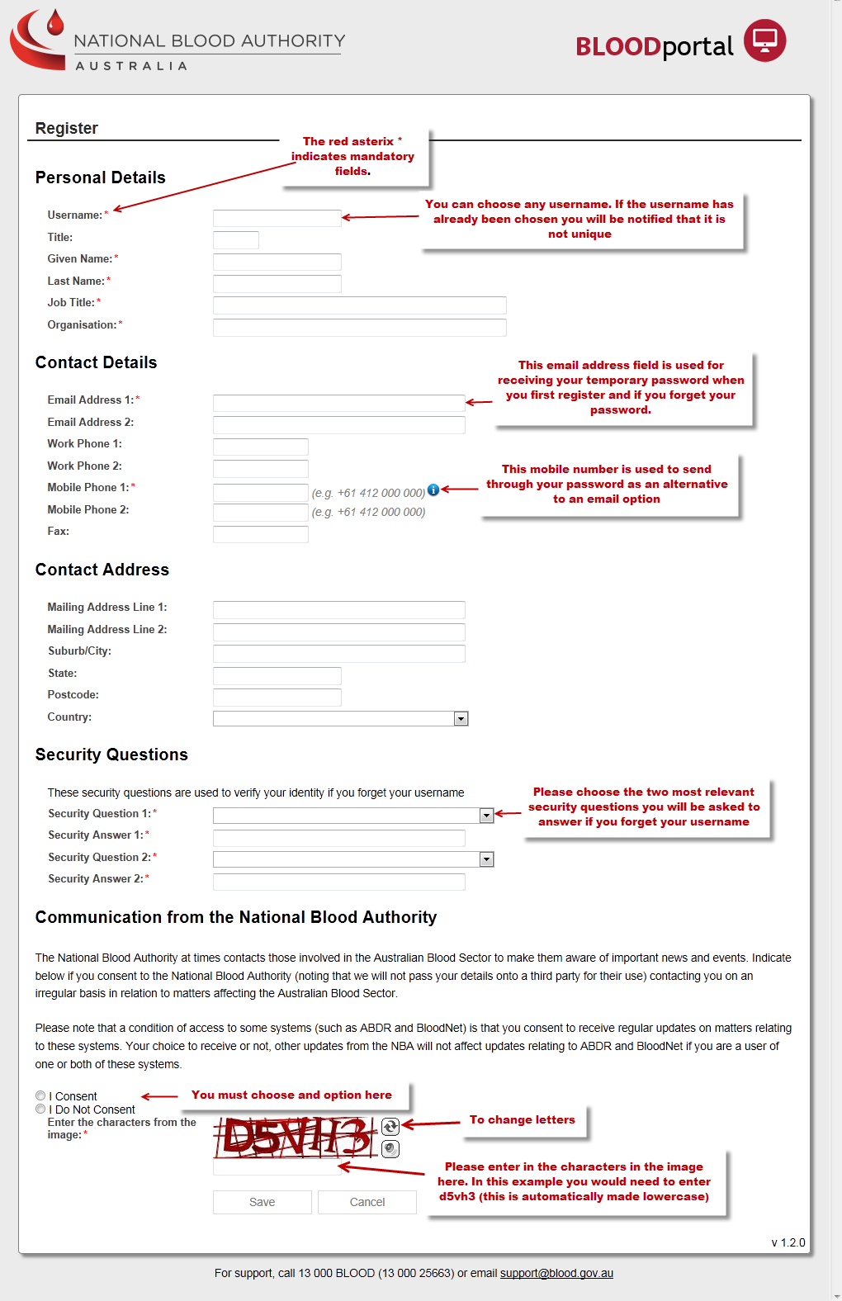

Step 2
After completing the form click the Save button. You will be presented with the screen below indicating that your account has been registered.

A temporary password will be sent through to your nominated email address and mobile phone number.

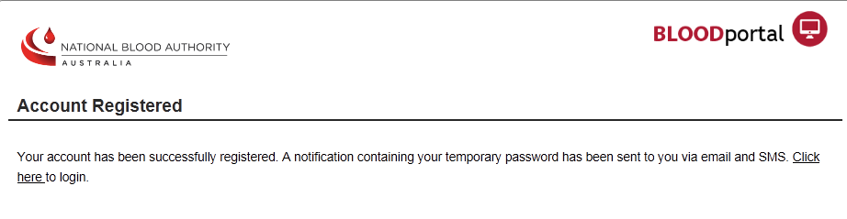
Step 3
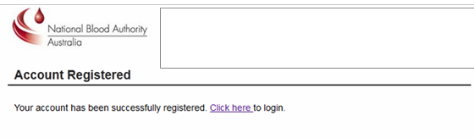

You have now finished registering your BloodPortal account.

The next step is to login and request access to BloodNet. Navigate in a web browser to https://portal.blood.gov.au . You will need to enter the username you created for BloodPortal above and the temporary password you should have now received via email or SMS. As this is the first time you are accessing the site you will be asked to change your password.

Step 4

After logging in you will see the BloodPortal home page as shown below. From here you can access My
Subscriptions for NBA Subscriptions, the blood sector chat forum BloodChat and the BloodNet application page.

Please click on the BloodNet link to request access to your BloodNet Facility as shown below.

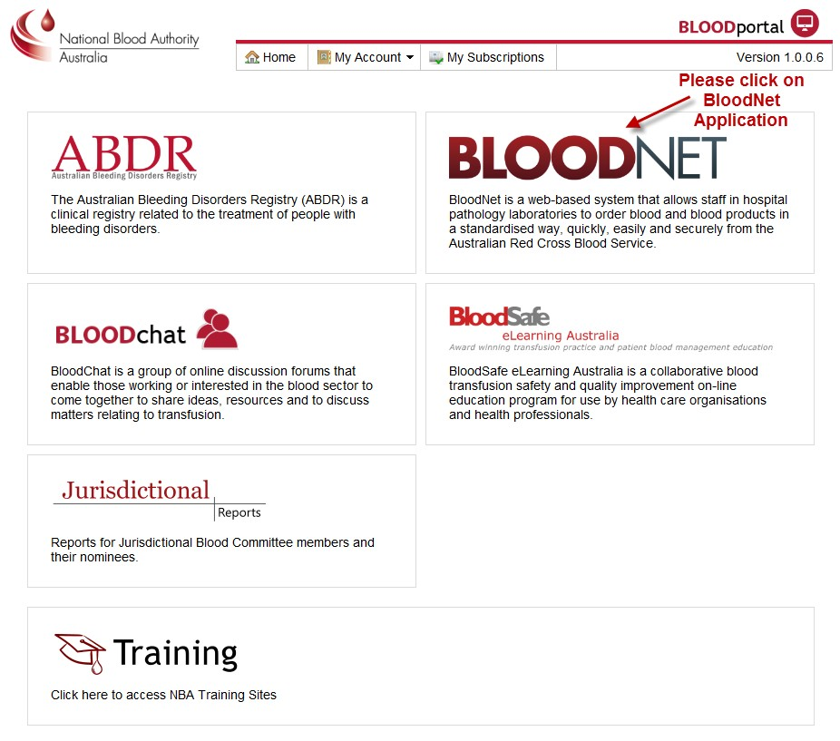

You will then be directed to the BloodNet Access Request and Approval page
Please click on Add Role and choose your state/territory, facility and most suitable role as outlined below. Please add all roles that are applicable to your employment (including various roles across multiple facilities if applicable).

Available Roles to choose from:

▪ Facility User: General users of BloodNet to order, receive and fate blood and blood products.

▪ Facility Administrator: Users of BloodNet with administrator rights which gives the ability to approve users, change templates and add news items. Once approved facility administrators will also be granted facility user access to the facility indicated.

▪ LIS Administrator: Responsible for monitoring and configuring anything required for LIS interfacing with BloodNet. You should only select this option if you are involved in implementing a BloodNet-LIS interface at your facility.

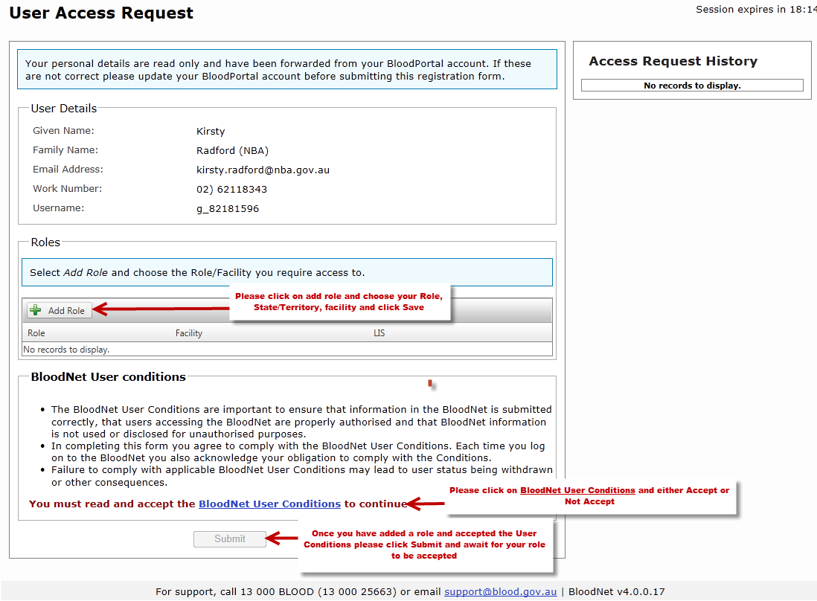

Once you have added all roles that apply to your position please click on the BloodNet User Conditions and read through and click to accept or not accept. This will then acknowledge your acceptance or rejection.

Finally, please click the Submit button. This will forward your access request to your facility administrator for approval.

Step 5

Please wait for your facility administrator (or the NBA if you are the first facility administrator to apply from your site) to approve your request. You will receive an email once the process is complete. Once one facility administrator is approved the NBA will no longer approve access to facilities or LIS BloodNet sites except in extenuating circumstances.

You can determine the status of your application on this screen anytime you are logged on by clicking the Access
Request link on the top right hand side of the screen, as can be seen in the above screenshot.

For Further Assistance

If you need further assistance please contact us on 13 000 BLOOD (13 000 25663) or email support@blood.gov.au.

