FATE: Allocate and Dispense
There are two Fate episode types associated with patient data: Allocate and Dispense.
Allocate episodes can be created when a unit has been allocated (either electronically or serologically) to a specific patient. Dispense episodes can be created when the unit has been sent to a ward or particular area for use by a patient.
Note: Once a unit has been Allocated or Dispensed, it must be Returned to Stock before another Fate can be applied. The only exception to this is a Transfer Episode, which can be done from either status.
To create either one of these episodes:
- Hover over the Fate tab and select New Fate Episode.
- From the different Fate types, select Allocate or Dispense.

- Fill in the required mandatory fields and scan the donation or lot number into the highlighted box. This will automatically enter the product into the Allocate or Dispense episode. If there are multiple items with that donation/lot number, it will prompt you to select the component from a list of possible options. Also enter as much patient information as possible, in case the episode needs to be referred to later.
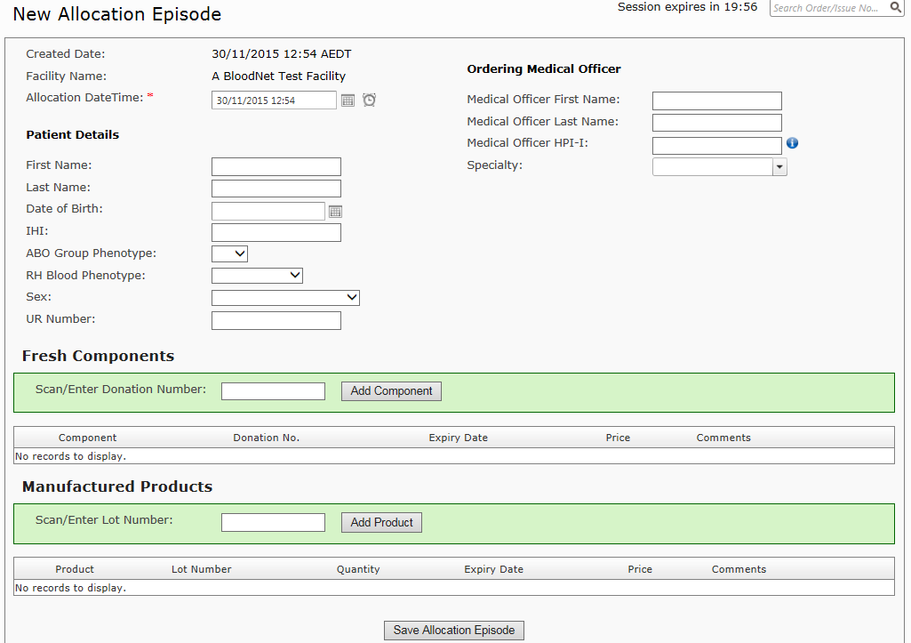
- Click Save Allocation/Dispense Episode. This will generate a Fate receipt that confirms the successful creation of an episode. The unit’s status will then be changed to Allocated/Dispensed.

