FATE: Conversion
A new Fate Conversion episode can be made if an FFP unit has been thawed and converted to ELP, or a Red Cell unit has been irradiated. To do so:
- Hover over the Fate tab and select New Fate Episode.
- From the different Fate types, select Conversion.
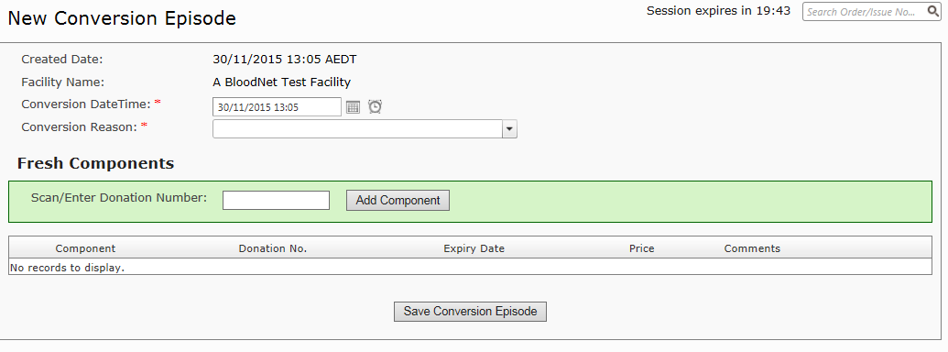
- Fill in the required mandatory fields and scan the donation or lot number into the highlighted box. This will automatically enter the product into the Conversion episode. If there are multiple products available with the same donation/lot number, it will prompt you to select the component type from a list.

- Click Save Conversion Episode. This will generate a Fate Episode Receipt and change the unit’s status in BloodNet.

Note: Converting a unit will not change the product type in BloodNet, however the conversion history will be recorded against the unit for fate search and record-keeping purposes.

