FATE: Return to Stock
A unit should have a Return to Stock episode created when it has been Allocated or Dispensed in BloodNet, but has been returned without being used for the patient. An Allocated or Dispensed unit must undergo a Return to Stock if it is to be discarded, allocated or dispensed again.
- Hover over the Fate tab and select New Fate Episode.
- From the different Fate types, select Return to Stock.
- Fill in the required mandatory fields and scan the donation or lot number into the highlighted box. This will automatically enter the product into the Return to Stock episode. If there are multiple components with the same donation/lot number, it will prompt you to select the component type from a list.
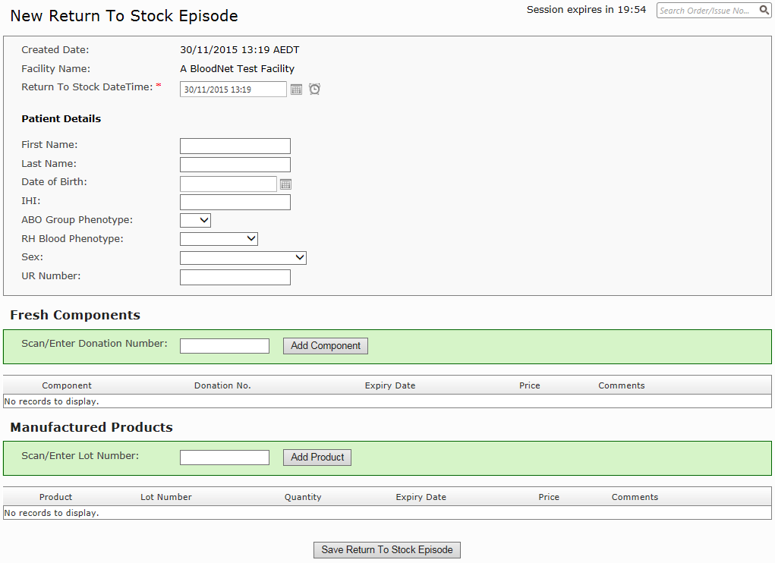
- Click Save Return to Stock Episode. This will complete the episode creation, generate a Fate Receipt with full details and change the status of the unit in BloodNet.

