**Patient Type** Counts the total number of patients registered at your HTC by Primary and Shared including the number using MyABDR if they were active at the HTC at any time during the selected month. The hyperlink drills down into more detailed data including a pie chart of Bleeding Disorder distribution by Bleeding Disorder Group; Bleeding Disorder Group by Age and a list of Primary and Shared patients. The data extract used to generate these summaries is also available.

**Report attributes in Header** shows standard details including logos, report title, security markings, Report Parameter: Month and Year selected and last time data was updated: NB Data for this report is summarised overnight, so only transactions performed prior to the time indicated in the header (next to **as at:**) will appear in the report.

**Last 12 Months** shows total numbers on each row for the selected month plus previous 11 months.

**Bleeding Disorder Group Counts by Severity** graphs bleeding disorders by severity for Primary and Shared patients based on each diagnoses, therefore the counts in this section will not reconcile with the Patient Type counts as one or more patients may have two or more diagnoses. Drill down data is available for this graph when clicked on. All bleeding disorders by severity will be graphed. Use the Bleeding Disorder and Severity Filters to refine the graph to meet your specific needs, or generate a graph for each bleeding disorder or severity patient cohort.

**Patient Transitions** Counts the total number of new patients transferred from other HTCs, patients transferred to other HTCs and number of patients who died. The hyperlink drills down into more detailed data on patient transitions.

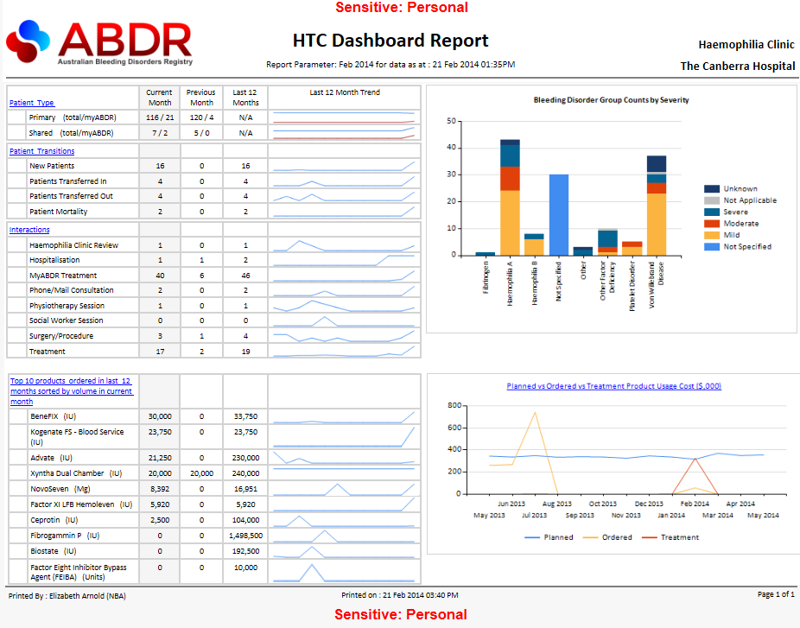

**Interactions** Displays number of commonly used interactions created at your HTC. MyABDR Treatments are included if your HTC is their primary HTC for the month selected in the report ..parameter.

**Top 10 Products in last 12 Months sorted by volume in current month** lists the 10 products with the highest volume ordered at your HTC in the last 12 months. The hyperlink drills down into more detailed data for the current month, includes cost information and all orders for current month. The report considers all HTC product orders and all Patient Product orders for each month but **excludes** all patient product orders that were supplied from ‘Hospital Blood Bank / HTC Stock’.

**Planned vs Ordered vs Treatment Product Usage Cost ($,000)** shows amount **Planned** (estimated using all treatment plan regimens [ie dose and frequency] excluding Regimen Type of Bleed) **vs** amount **Ordered** for HTC Product Orders and Patient Product Orders excluding those supplied from ‘Hospital Blood Bank / HTC Stock’ **vs** amount used in **Treatments** in ABDR Treatment Interactions and MyABDR Treatments (Primary).

**Current Month** shows the total number of all records for row for the month selected in the report parameter.

**Report attributes in footer** shows standard details including security markings, date report was printed, by whom, and number of pages.

**Previous Month** shows the total number of all records for the row for the month previous to the month selected in the report parameter.

**Last 12 Month Trend** is a spark line showing of total number of records for each of the last 12 months where the last month in this period is equal to the month selected in the report parameters.