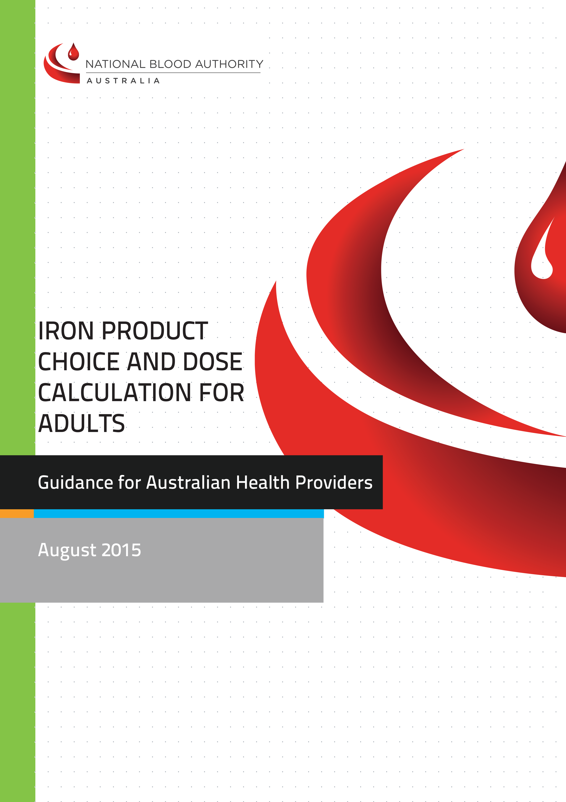

With the exception of any logos and registered trademarks, and where otherwise noted, all material presented in this document is provided under a Creative Commons Attribution 3.0 Australia (http://creativecommons.org/ licenses/by/3.0/au/) licence.

The details of the relevant licence conditions are available on the Creative Commons website (accessible using the links provided) as is the full legal code for the CC BY 3.0 AU license (http://creativecommons.org/licenses/by/3.0/au/legalcode).

The content obtained from this document or derivative of this work must be attributed as the Iron Product Choice and Dose Calculation.

© National Blood Authority, 2015.
ISBN : 978-0-9924971-9-4
This report is available online at: www.blood.gov.au

For more information:
Patient Blood Management
National Blood Authority
Locked Bag 8430 Canberra ACT 2601
Phone: 13000 BLOOD (13 000 25663)
Email: patientbloodmanagement@blood.gov.au www.blood.gov.au

>IRON PRODUCT CHOICE AND
DOSE CALCULATION – ADULTS
This guide has been developed to assist clinicians determine the appropriate formulation and dosage of iron replacement therapy for adults who have been diagnosed with iron deficiency (ID) and/or iron deficiency anaemia (IDA).
Iron requirements for infants, children and adolescents are included in Chapter 4 of the Patient Blood Management Guidelines: Module 6 Neonatal and Paediatric (in development)
For resources on aetiology, prevention, diagnosis and investigation of iron deficiency refer to Appendix 1.

IRON FORMULATIONS
All patients with ID should have iron supplementation to correct anaemia and/or replete body stores.¹⁻³
Patients should be provided with information brochures about the iron therapy prescribed.
Diet
Increase in dietary iron may be valuable for secondary prevention of iron deficiency¹ but should not be relied upon as treatment. Consider referral to an Accredited Practising Dietician.

Oral therapy
Oral iron therapy is suitable and effective as first line therapy in most patients with iron deficiency or iron deficiency anaemia.¹ When given at equivalent elemental iron doses, different oral iron salts have similar efficacy and tolerability.¹

Intramuscular therapy
Intramuscular (IM) iron is effective but painful and may be associated with permanent skin staining. It is no safer than IV infusion.¹ Its use is discouraged.^{1,2}

Intravenous therapy
Three preparations of intravenous iron (IV) are approved for IV use in Australia:
- Ferric carboxymaltose: Ferinject®
- Iron polymaltose: Ferrosig®
- Iron sucrose: Venofer®
See Appendix 2 for indications and comparison information.

Making the choice
Oral iron therapy is suitable and effective as first line therapy in most patients, including most obstetric patients,^{4,5} with iron deficiency or iron deficiency anaemia.¹ Indications for intravenous iron include:^{1,3,5,6}
- contraindications to oral iron, or compliance or tolerance (side effect) issues
- pregnancy (beyond the first trimester) and postpartum if oral iron not suitable or effective, or to prevent physiological decompensation
- comorbidities which may impact on absorption (eg. intestinal mucosal disorders), or bone marrow response
- chronic renal impairment receiving erythropoiesis-stimulating agent therapy
- ongoing iron losses that exceed absorptive capacity
- requirement for rapid iron repletion (eg. prevention of physiological decompensation or preoperatively for non-deferrable surgery)

Although the initial rise in haemoglobin (Hb) is more rapid with parenteral iron, the rise in Hb at 12 weeks is similar to that observed during oral iron therapy.³

Availability of IV preparations, dosing schedules and facilities for administration are also important considerations.

IRON DOSE
Oral therapy
The usual recommended dose in adults is 100–200 mg of elemental iron daily, in 2 to 3 divided doses.¹ Lower doses may be as effective and better tolerated.¹ In maternity patients with iron deficiency without anaemia, a low dose of elemental iron (eg. 20-80 mg daily) may be considered, and may be better tolerated than higher doses.⁵
More than 100 preparations containing iron are available over the counter in Australia; however few contain sufficient elemental iron to treat IDA effectively.¹ Appropriate formulations are outlined in the Oral preparations for treatment of iron deficiency anaemia (IDA) chart (Appendix 3). Multivitamin-mineral supplements should not be used to treat IDA as iron content is low and absorption may be reduced.¹
After therapeutic doses of oral iron, reticulocytosis should occur within 72 hours, and Hb levels should rise by about 20 g/L every 3 weeks. Oral iron should be continued for 3 months after anaemia has been corrected to replenish stores.^{1,3} Inadequate response to oral iron therapy can be due to a number of factors, such as inadequate intake or absorption, ongoing losses, coexisting conditions or incorrect diagnosis, with more than one often being involved.¹

INTRAVENOUS THERAPY
Calculating total body iron deficit
The patient’s total body iron deficit (cumulative amount of iron required to replete body iron stores) is NOT the same as the allowable iron dose per infusion which is DIFFERENT for each product. Calculate the deficit to determine how many doses of the desired preparation is required. Refer to the specific product information and local administration guidelines for information on the maximum iron dose per infusion for each product (Appendix 2).
The cumulative dose for repletion of iron is based on the patient’s Hb and body weight and should not be exceeded. There are two methods for determining the cumulative dose – the Ganzoni formula⁷ and the Simplified Method.⁸
Ganzoni formula:
Total body iron deficit/cumulative iron dose (mg) =
body weight* (kg) x (target Hb – actual Hb in g/L) x 0.24** + iron depot (mg)***

*Use ideal body weight in overweight patients. If underweight, use actual body weight
**The factor 0.24= 0.0034 x 0.07 x 1,000:
For this calculation the iron content of haemoglobin = 0.34%,
blood volume = 7% of the bodyweight, and
1,000 is the conversion from g to mg
***Iron depot:
<35 kg body weight: iron depot = 15 mg/kg body weight
≥35 kg body weight: iron depot = 500 mg

For example a 70 kg female with Hb 80 g/L has an iron deficit of:
70 x (150 – 80) x 0.24 + 500 = 1676 mg i.e. approx. 1700 mg

Note that the target Hb may vary according to patient population. The UK guidelines on the management of iron deficiency in pregnancy⁴ recommend a target Hb of 110 g/L, based on pre-pregnancy weight, in women from the second trimester onwards and postpartum period, with iron deficiency anaemia who fail to respond to, or are intolerant of, oral iron. Refer to local policies and procedures.

Simplified Method:
To date only the product information (PI) of Ferinject® incorporates the Simplified Method. However, expert practice and published localised drug guidelines^{9,10} now reflect this change.
The following table can be used for estimating the cumulative amount of iron required to replete body iron stores (for adult patients of body weight ≥ 35 kg).
Estimated cumulative iron dose
Hb g/L | Body weight 35 kg to <70 kg* | Body weight ≥70 kg*
<100 g/L | 1,500 mg | 2,000 mg
≥100 g/L | 1,000 mg | 1,500 mg
*Use ideal body weight in overweight patients. If underweight, use actual body weight

Caution is recommended with the Simplified Method as it is based on experience in a single clinical trial in adults with inflammatory bowel disease with a median Hb 104 g/L (range 61-146 g/L) and body weight ≥ 35 kg. Seek expert advice from a haematologist if in doubt.

Administration
Infusion rates, maximum dose per infusion and dilution are NOT interchangeable between IV iron products. Refer to the specific product information and administration guidelines.
Oral iron is not required after IV iron is given if the total iron deficit has been (or will be) repleted with IV iron therapy.
A “total-dose” infusion (where iron stores can be repleted in a single treatment episode) can be administered with iron polymaltose and in mild cases of IDA with ferric carboxymaltose, however iron sucrose requires multiple small intermittent doses over days to weeks.
Anaphylaxis may occur with IV iron and resuscitation facilities should be available.¹¹ It would appear that iron polymaltose may have a higher incidence of severe systemic reactions than iron sucrose and ferric carboxymaltose.
Hypophosphataemia has been reported with all three intravenous iron preparations and may be more common and severe with ferric carboxymaltose. Caution should be taken with patients at risk.
All three iron preparations have similar mild adverse event profiles.^{1,3}

> REFERENCES
- Pasricha SR, Flecknoe-Brown SC, Allen KJ, Gibson PR, McMahon LP, Olynyk JK, et al. Diagnosis and management of iron deficiency anaemia: a clinical update. MJA 2010;193:525–532. Available at: http://www.mja.com.au.

- Gastroenterological Society of Australia. Clinical update: Iron deficiency, First Edition. Sydney, Australia, Digestive Health Foundation, 2008. Available at: http://www.gesa.org.au.

- Goddard AF, James MW, McIntyre AS, Scott BB on behalf of the British Society of Gastroenterology. Guidelines for the management of iron deficiency anaemia. Gut 2011;60:1309–1316. Available at: http://www.bsg.org.uk.

- Pavord, S., Myers, B., Robinson, S., Allard, S., Strong, J., Oppenheimer, C. and on behalf of the British Committee for Standards in Haematology. UK guidelines on the management of iron deficiency in pregnancy. British Journal of Haematology 2012;156:588–600. Available at: http://www.bcshguidelines.com

- National Blood Authority. Patient Blood Management Guidelines: Module 5 – Obstetrics and Maternity. Australia, 2015. Available at: http://www.blood.gov.au/pbm-module-5

- National Blood Authority. Patient Blood Management Guidelines: Module 2 – Perioperative. Australia, 2012. Available at: http://www.blood.gov.au/pbm-module-2

- Ganzoni AM. Intravenous iron-dextran: therapeutic and experimental possibilities. Schweiz Med Wochenschr. 1970;100:301–303. Available at: http://www.ncbi.nlm.nih.gov/pubmed/5413918

- Evstatiev R, Marteau P, Iqbal T, Khalif IL, Stein J, Bokemeyer B, et al;FERGI Study Group. FERGIcor, a randomized controlled trial on ferric carboxymaltose for iron deficiency anemia in inflammatory bowel disease. Gastroenterology 2011;141:846-853.e2. Available at: http://www.ncbi.nlm.nih.gov/pubmed/21699794

- SA Maternal & Neonatal Clinical Network. Policy. Clinical Guideline. South Australian Perinatal Practice Guidelines – iron infusion. Approved 10 June 2014. Available at: http://www.sahealth.sa.gov.au/wps/wcm/connect/public+content/sa+health+internet/resources/policies/iron+infusion+-+sa+perinatal+practice+guidelines [accessed January 2015]

- Fremantle Hospital and Health Service, Department of Pharmacy. Specialised Drug Guideline – Ferric Carboxymaltose. Available at: http://www.health.wa.gov.au/bloodmanagement/docs/default.carboxy.pdf [accessed June 2014]

- National Prescribing Service (NPS). Ferric carboxymaltose (Ferinject) for iron deficiency anaemia. NPS Radar. Published 1 August 2014. Available at: http://www.nps.org.au/publications/health-professional/nps-radar/2014/july-2014/ferric-carboxymaltose

>APPENDIX 1: IRON THERAPY RESOURCES
Iron deficiency anaemia guidelines/references:
Pasricha SR, Flecknoe-Brown SC, Allen KJ, Gibson PR, McMahon LP, Olynyk JK, et al. Diagnosis and management of iron deficiency anaemia: a clinical update. MJA 2010;193:525–532. Available at: http://www.mja.com.au

Gastroenterological Society of Australia. Clinical update: Iron deficiency, First Edition. Sydney, Australia, Digestive Health Foundation, 2008. Available at: http://www.gesa.org.au

Goddard AF, James MW, McIntyre AS, Scott BB on behalf of the British Society of Gastroenterology. Guidelines for the management of iron deficiency anaemia. Gut 2011;60:1309–1316. Available at: http://www.bsg.org.uk

Pavord, S., Myers, B., Robinson, S., Allard, S., Strong, J., Oppenheimer, C. and on behalf of the British Committee for Standards in Haematology. UK guidelines on the management of iron deficiency in pregnancy. British Journal of Haematology 2012;156:588–600. Available at: http://www.bcshguidelines.com

Minck S, Robinson K ,Saxon B, Spigiel T, Thomson A. Patient Blood Management the GP’s guide. Australian Family Physician 2013;42:291-297. Available at: http://www.racgp.org.au/afp

Iron deficiency anaemia education/information/tools:
BloodSafe eLearning Australia:
- Iron deficiency anaemia algorithm app (iPhone, iPad, Android)
- Iron deficiency anaemia course
Available at: https://www.bloodsafelearning.org.au

Australian Red Cross Blood Service information about Iron deficiency anaemia:
- Treatment Options for Iron Deficiency Anaemia
- Major Reasons for Inadequate Response to Oral Iron Therapy
- Oral Iron Therapy Interactions and Management
- Oral Iron Therapy Side Effects and Management
- Spectrum of iron deficiency
Available at: http://www.transfusion.com.au

Intravenous iron references
Product information for intravenous iron preparations available in Australia:
- Ferric carboxymaltose: Ferinject®
- Iron polymaltose: Ferrosig® and Ferrum H®
- Iron sucrose: Venofer®
Available at: http://www.ebs.tga.gov.au

Australian Injectable Drugs Handbook (AIDH)
- Ferric carboxymaltose
- Iron polymaltose complex
Available at: http://www.shpa.org.au/Publications/Australian-Injectable-Drugs-Handbook
(note: AIDH requires subscription; however the above pages are accessible)

Guiding principles for the development of intravenous (IV) iron infusion practice developed for Victorian health services
- Additional resources from Victorian health services
  - Ballarat Health 2010 Iron Polymaltose infusion policy
  - Iron carboxymaltose Administration guidelines 2012 : Peter MacCallum Cancer centre
Available at: http://www.health.vic.gov.au/bloodmatters/management/guiding_principles_iron_infusion.htm

Fremantle Hospital and Health Service, Department of Pharmacy. Specialised Drug Guidelines regarding intravenous iron use:
- Iron carboxymaltose
- Iron polymaltose
- Iron sucrose
Available at: http://www.health.wa.gov.au/bloodmanagement

SA Maternal & Neonatal Clinical Network. Policy. Clinical Guideline. South Australian Perinatal Practice Guidelines – iron infusion.
Available at: http://www.sahealth.sa.gov.au

National Prescribing Service (NPS). Ferric carboxymaltose (Ferinject) for iron deficiency anaemia.
Available at: http://www.nps.org.au

Gozzard D. When is high-dose intravenous iron repletion needed? Assessing new treatment options. Drug Des Devel Ther. 2011;20:51-60. Available at: http://www.pubmed.gov

Auerbach M, Ballard H. Clinical use of intravenous iron: administration, efficacy, and safety. Hematology Am Soc Hematol Educ Program. 2010;2010:338-47. Available at: http://www.pubmed.gov

Guiding Principles for the use of off-label medicines:
Council of Australian Therapeutic Advisory Groups (CATAG). Guiding Principles for the quality use of off-label medicines. November 2013. Available at: http://www.catag.org.au/wp-content/uploads/2012/08/OKA9963-CATAG-Rethinking-Medicines-Decision-Making-final.pdf

Healthcare professional resources
Dieticians Association of Australia
Available at: http://daa.asn.au/

Patient Blood Management Guidelines
- Module 2 Perioperative
- Module 3 Medical
- Module 5 Obstetrics and Maternity
Available at: http://www.blood.gov.au

BloodSafe Oral iron therapy dosing chart
Available at: http://www.bloodsafe.sa.gov.au

Resources for patients
BloodSafe Iron therapy brochures for patients (oral)
Available at: http://www.bloodsafe.sa.gov.au

BloodSafe: Intravenous (IV) iron infusions
Available at: http://www.bloodsafe.sa.gov.au

Intravenous (IV) iron infusions: Fremantle Hospital and Health Service
Available at: http://docs.health.vic.gov.au/docs/doc/Intravenous-iron-infusions:-Freemantle-Hospital-and-Health-Service

Australian Red Cross Blood Service patient website: iron deficiency anaemia for patients
Available at: http://mytransfusion.com.au
This page is intentionally blank

>APPENDIX 2: INTRAVENOUS IRON PREPARATIONS COMPARISON INFORMATION (AS PER PRODUCT INFORMATION)
 | Ferric carboxymaltose | Iron sucrose | Iron polymaltose
Indication | Treatment of (laboratory diagnosed) iron deficiency when oral iron preparations are ineffective or cannot be used. | The treatment of (laboratory diagnosed) iron deficiency anaemia in patients undergoing chronic haemodialysis and who are receiving supplemental erythropoietin therapy. | Treatment of iron deficiency anaemia when oral therapy is contraindicated, enteric absorption of iron is defective or when patient non-compliance or persistent gastrointestinal intolerance makes oral therapy impractical.
Iron concentration (mg/mL) | 50 mg/mL | 20 mg/mL | 50 mg/mL
Presentation | 2 mL (100 mg ) or 10 mL (500 mg) vial | 5 mL ampoules | 2 mL ampoules
Maximum dose in a single administration for patients ≥35 kg | 1000 mg (not more than 1000 mg per week)  (max 20 mg iron/kg body weight*) | 100 mg not more than 3 times per week  Most patients will require a minimum cumulative dose of 1000mg | 2500 mg
Frequency of administration | IV infusion: do not give more than1000mg iron per week. Do not exceed calculated cumulative iron dose or 20 mg iron/kg body weight.  IV bolus injection: max dose of 200mg no more than 3 times a week. | 100mg no more than three times per week.
Rate of administration | IV infusion:  100-200 mg 3 minutes  >200-500 mg 6 minutes  >500-1000 mg 15 minutes  IV bolus injection:  200-500 mg @ 100 mg/min  >500 – 1000 mg over 15 mins | Intravenous infusion 100 mg over 15 minutes.  For haemodialysis patients may be given slow IV injection into the venous limb of the dialysis line at 1 mL (20 mg iron) per minute (ie. 5 minutes per ampoule) | The first 50 mL should be infused slowly at 20-40 mL/hour  If tolerated may be increased to 120 mL/hour  Note: see links below for rapid infusion information
Total dose single infusion | No  (Unless total body iron deficit is <1000 mg) | No | Yes
Link to Product information | Ferinject® | Venofer® | Ferrosig® and Ferrum H®†
*Use ideal body weight in overweight patients. If underweight, use actual body weight
†Whilst considered brand equivalent to Ferrosig®, Ferrum H® is not licensed for intravenous use in Australia – refer to Guiding Principles for the use of off-label medicines.¹
See over for important consideration
Important considerations
Always refer to local health service guidelines/protocols and product information for the specific iron preparation. Maximum doses per infusion, infusion rates and dilution are not interchangeable between the different IV iron preparations.
Emerging data and regional practice indicate that alternative dosing and infusion schedules may be practical and safe.¹⁻³
There is also evolving evidence regarding the appropriateness of the three IV iron preparations in varying clinical circumstances. If in doubt, refer to local guidelines/protocols or consult with an expert haematologist.
Note: TEST DOSE NOT REQUIRED - The European Medicines Agency’s (EMA) Committee for Medicinal Products for Human Use (CHMP)⁴ has considered that the current practice of first giving the patient a small test dose is not a reliable way to predict how the patient will respond when the full dose is given. A test dose is therefore no longer recommended but instead caution is warranted with every dose of intravenous iron that is given, even if previous administrations have been well tolerated.⁴
Current IV iron Product Information (PI) can be found on the Therapeutic Goods Administration website: www.ebs.tga.gov.au - click on "Public TGA Information" in menu bar on left then click on Product Information and enter product name in search box.

References:
- Evstatiev R, Marteau P, Iqbal T, Khalif IL, Stein J, et al; FERGI Study Group. FERGIcor, a randomized controlled trial on ferric carboxymaltose for iron deficiency anemia in inflammatory bowel disease. Gastroenterology 2011;141:846-853.e2.
- SA Maternal & Neonatal Clinical Network. Policy. Clinical Guideline. South Australian Perinatal Practice Guidelines – iron infusion.
Available at: http://www.sahealth.sa.gov.au
- Fremantle Hospital and Health Service, Department of Pharmacy. Specialised Drug Guidelines regarding intravenous iron use: Iron sucrose.
Available at: http://www.health.wa.gov.au/bloodmanagement
- European Medicines Agency (EMA). New recommendations to manage risk of allergic reactions with intravenous iron-containing medicines. 28 June 2013. Available at: http://www.ema.europa.eu/docs/en_GB/document_library/Press_release/2013/06/WC500144874.pdf
- Council of Australian Therapeutic Advisory Groups (CATAG). Guiding Principles for the quality use of off-label medicines. November 2013. Available at: http://www.catag.org.au/wp-content/uploads/2012/08/OKA9963-CATAG-Rethinking-Medicines-Decision-Making-final.pdf

>APPENDIX 3: ORAL PREPARATIONS FOR TREATMENT OF IRON DEFICIENCY ANAEMIA (IDA)
IN AUSTRALIA*
NAME  (Manufacturer) | TABLET | FORMULATION | ELEMENTAL  IRON CONTENT
FERRO-LIQUID  (AFT pharmaceuticals)  PBS listed |  | Ferrous Sulphate  Oral solution | 30 mg/5 mL
FEFOL® Iron and folate supplement  (Pharm-a-care) | 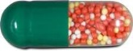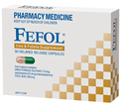 | Ferrous Sulphate 270 mg  Folic acid 300 mcg  Delayed release capsule | 87.4 mg
Ferro-f-tab  (AFT pharmaceuticals) | 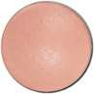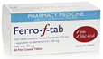 | Ferrous Fumarate 310 mg  Folic acid 350 mcg | 100 mg
Ferro-tab  (AFT pharmaceuticals) | 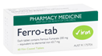 | Ferrous Fumarate 200mg | 65.7 mg
FERRO-GRADUMET  (Abbott) | 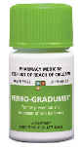 | Ferrous Sulphate 325 mg  Modified release tablet | 105 mg
FERRO-GRAD C  (Abbott) | 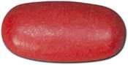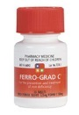 | Ferrous Sulphate 325 mg  Ascorbic acid 500 mg  Modified release tablet | 105 mg
FGF  (Abbott) | 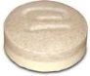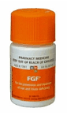 | 250 mg  Ferrous Sulphate  Modified release tablet | 80 mg

#Maltofer  (Aspen Pharmacare) | 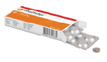 | Iron polymaltose 370 mg | 100 mg
#Maltofer Syrup  (Aspen Pharmacare) | 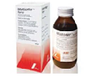 | Iron polymaltose 185 mg  Oral solution | 50 mg/5 ml

# Response to oral iron polymaltose (Maltofer) may be slower than with ferrous iron. Maltofer is licenced in Australia for treatment of iron deficiency in adults and adolescents where the use of ferrous iron supplements is not tolerated, or otherwise inappropriate.
* Modified from: BloodSafe Oral Iron Table Version 1.7 October 2011, TP-L3-410. Available at: http://www.bloodsafe.sa.gov.au
See below for dosing and considerations
Dosing and considerations:
- Usual ADULT dose for IDA is around 100–200 mg elemental iron daily in divided doses
- Ideally give 1 hr before or 2 hrs after food
  - GI upset may be reduced by taking tablet with food or at night & increasing dose gradually
- Consider giving supplement with Vitamin C (eg. orange juice) to improve absorption
- When a rapid increase in Hb is not required, intermittent dosing (1 tablet 2–3 times a week) or lower doses of iron (e.g. 30–60 mg of elemental iron, increasing to twice daily or three times a day if tolerated: try Ferro-tabs or titrate liquid) may reduce GI upset
- Multivitamin-mineral supplements should not be used to treat IDA as iron content is low and absorption may be reduced
- Iron overdose may be fatal – keep medication out of reach of children
- Based on limited available data, controlled-release iron formulations appear to have fewer GI side effects, but similar discontinuation rates and comparable efficacy; release of iron distal to the site of maximal intestinal absorption may theoretically limit response in some patients.¹

