Ordering Patient Cards from MyABDR

(Website only)
With the update to MyABDR (web only) on Saturday 17 October 2015 you will be able to order Patient Cards directly rather than through your Haematology Treatment Centre (HTC). Patient cards contain your identification details as well as your diagnosis, treatment guidelines, and HTC contact details. A patient card is provided to be presented at a non-HTC Hospital/GP if treatment is required. Patient cards are supplied free of charge by the National Blood Authority.
To order a patient card in MyABDR please follow the steps detailed below:
- Open up a web browser (Internet explorer, Chrome, Firefox, etc.) on your computer and type into the address bar https://www.myabdr.blood.gov.au

- Enter your email address and password and then press enter or click Login.

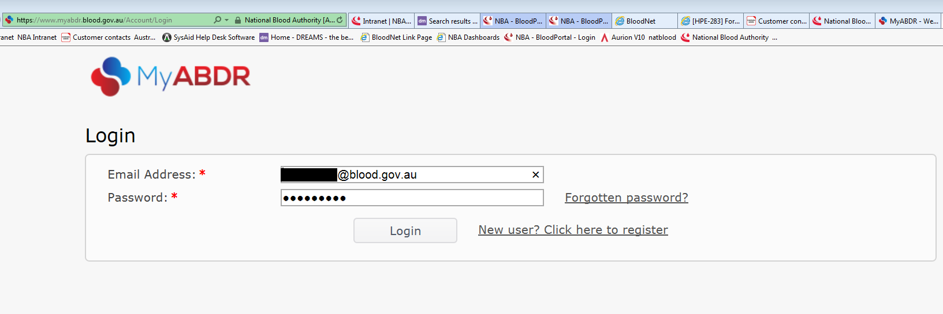
- You should now see the Welcome to MyABDR page. From this page move your cursor over the Details drop down menu towards the top of the screen. A menu will appear, click on the Patient Cards option.
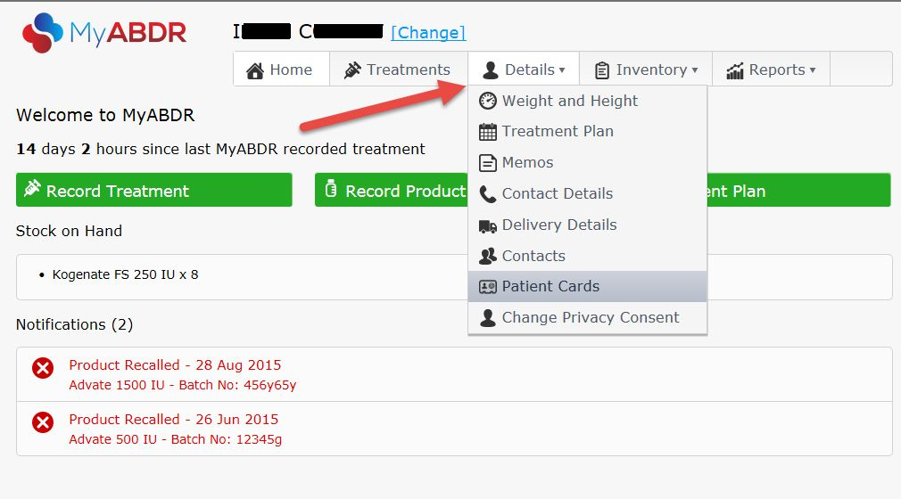
- You should now be on the Patient Card Orders page. This page details the status of current and previous patient cards. To place a new card request click on Request Card.
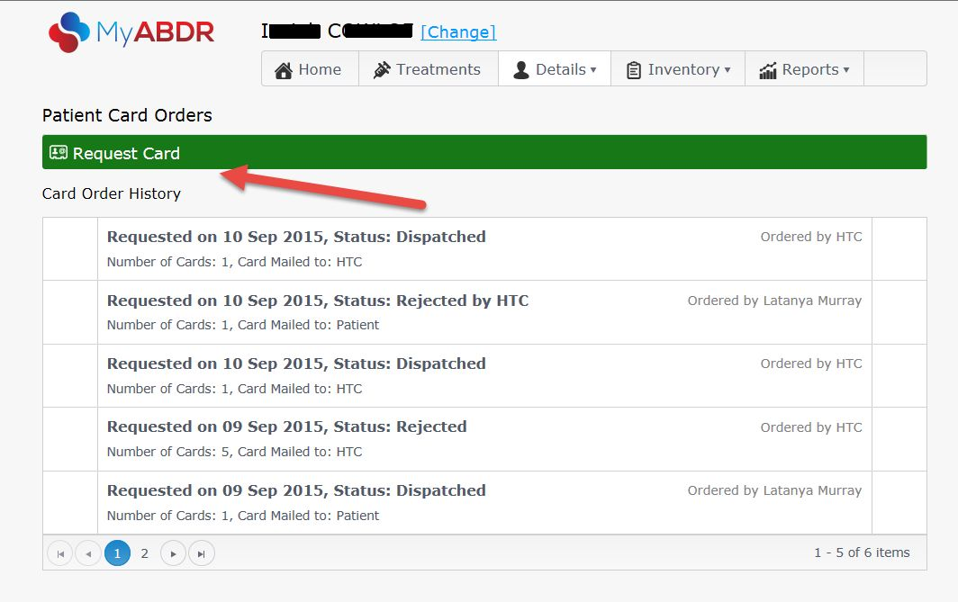

- A pop up window will appear. Enter the number of cards you require and choose if you would like the card delivered to your home or your HTC. Enter any special instructions for the ABDR Support team regarding the production or delivery of the card.
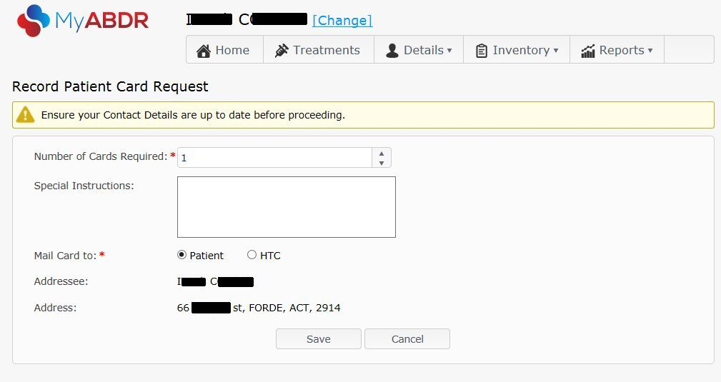
If you choose to have your patient card delivered to your HTC they will mail the card to you or give you your card in person on your next visit.
If you choose to have the card delivered to your home please ensure your address details are up to date before clicking the Save button.
Please note: To permanently update your address details select the Delivery Details option from the Details drop down menu.
- Your card request should now appear at the top of your Card Order History on the Patient Card Orders page.

You can edit a patient card request by clicking on the pencil icon or cancel a request by clicking on the trash can icon. Patient card requests can be edited or cancelled up until the point they are marked as dispatched.

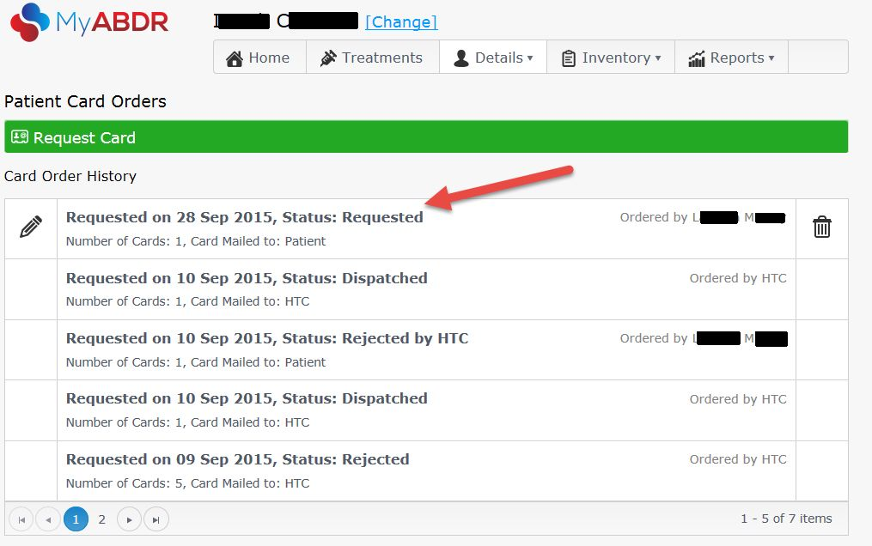

- Once you submit a card request it will be reviewed by your HTC and approved for the ABDR Support team to print and mail out to the allocated address. You can monitor the status of a card request by checking back to the Patient Card Orders page.

If you require further assistance with this process, please contact the National Blood Authority on 13 000 BLOOD (13 000 25663) or email myabdr@blood.gov.au.

