Setting a PIN code (Mobile app only)
The National Blood Authority is rolling out the new functionality of a simple four digit pin lock requirement. This will enhance the ‘remember me’ functionality and protect sensitive information in the ABDR/MyABDR system.
Previously users have been able to login with their email address and password once and select the ‘Remember me?’ option. This allowed the user to log in without entering their account details. The ‘Remember me?’ function has been enhanced and users who wish to have the app remember their details will now need to set a simple 4 digit PIN (Personal Identification Number). The user can then log in with the PIN in the future while the ‘Remember my details’ function is activated instead of their email and password.

To set your PIN please follow the steps below

Step 1. Open the MyABDR mobile app, enter your email address and password and then tap on the ‘Remember my details’ button.

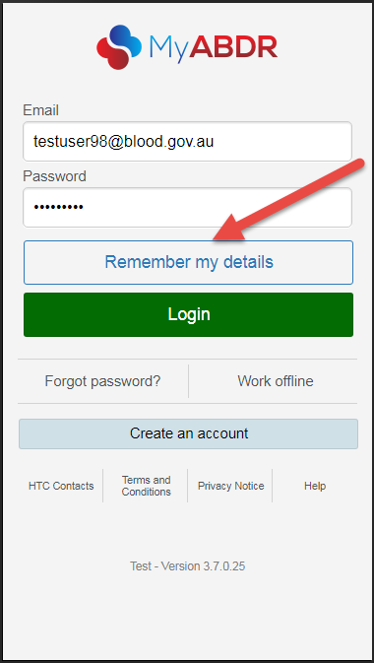
Step 2. A pop up window will appear which will ask you if you would like to set a PIN to access MyABDR without entering your email and password. Tap on the ‘Yes, I’ll set a PIN’ button to proceed.

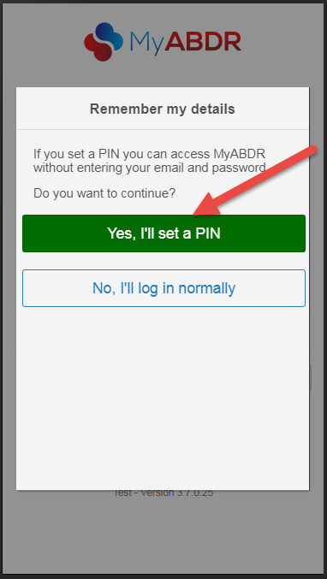

Step 3. The app will check that your email address and password details are correct and then take you to an ‘Enter PIN’ screen. Enter a 4 digit PIN of your choice by tapping on the number pad on your screen.

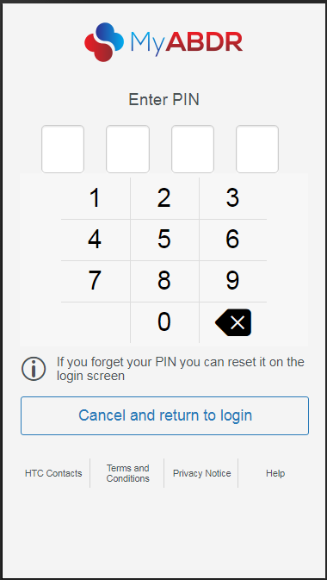

Step 5. You will then be logged in to your account and taken to the home page.

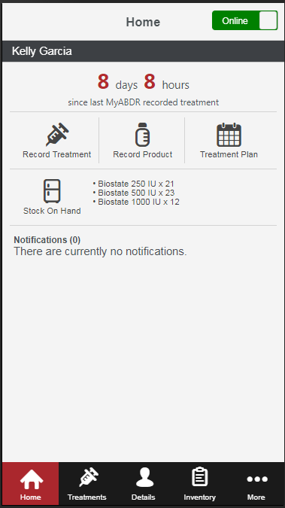

Step 4. You will then be prompted to confirm your PIN. Re-enter the 4 digit number.

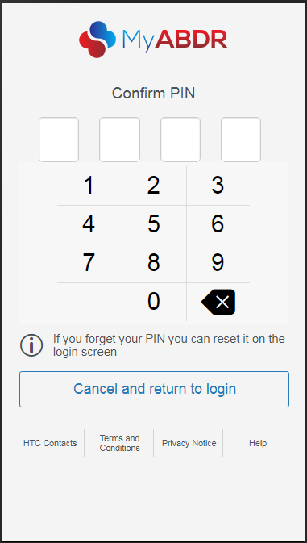

Changing your PIN code
To change your PIN follow the steps below
Step 1. From the PIN log in page tap on the ‘Reset or remove PIN’ button.
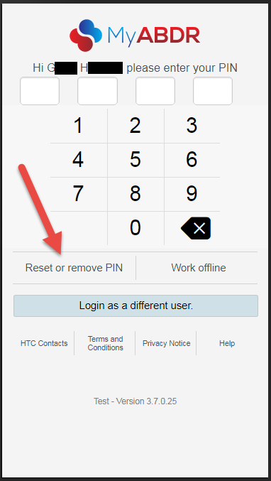

Step 2. A pop up window will appear. Click on the ‘Continue to login’ button to continue.
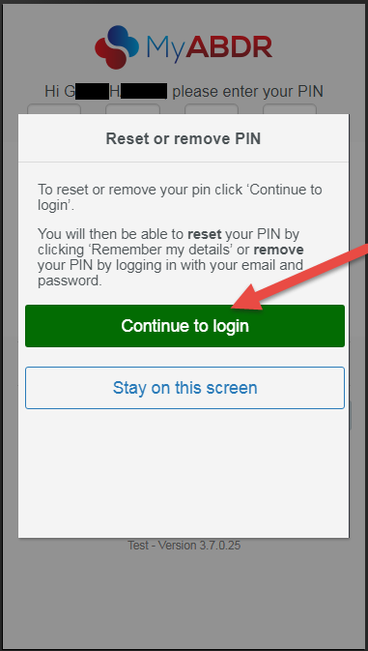

Step 3. Follow steps 1 – 4 from the ‘Setting
your PIN code’ instructions listed on pages
1 -2 of this document.

Please note, if you are already logged in to your account and wish to change your PIN code you will need to log out first. Once you have logged out you will be taken to the log in page where you will need to enter your email address and password and then tap on the Remember my details button. From this point you can follow steps 1 – 4 from the ‘Setting your PIN code’ instructions listed on pages 1 -2 of this document.

Troubleshooting
- Forgotten PIN code - If you are unsuccessful at entering your PIN on 3 attempts you will be taken back to the original log in screen where you are required to enter your email address and password. You may then tap on the ‘Remember my details’ button to set a new PIN code or the ‘Login’ button to log in without the app remembering your details.

- Removing your PIN code - From the PIN Log in screen tap on the Reset or remove PIN button. You will be taken back to the original log in screen where you will need to enter your email address and password and then tap on the Login button. Removing the PIN function means you will now be required to log in with your email address and password each time you use the app.

- Managing multiple users on the same device – Setting a PIN code is not recommended in the situation where multiple MyABDR users manage their accounts on the same device as users are required to enter their email address and password when switching between accounts.

