BloodNet is Australia-wide

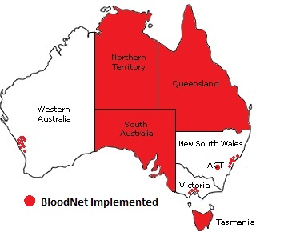
From this week, BloodNet will be operating in some capacity in all Australian states and territories.

The red areas in the map above show BloodNet’s footprint across the nation. Four jurisdictions now use BloodNet in all hospitals (public and private) – Tasmania, Queensland, South Australia and the Northern Territory. It already has some presence in Victoria and is now successfully operating in the private sector in Perth.

Over the last fortnight, BloodNet has taken its first steps into New South Wales and the Australian Capital Territory to establish its presence nationwide. Key dates in this next stage of the roll-out are:
- Six South Eastern Area Laboratory Services (SEALS) sites stretching from Sydney’s south-east suburbs to Wollongong, started on 22 August
- All public and private hospitals in Canberra started on 29 August
- Regional private hospitals in Western Australia started on 22 August.
With the implementation of BloodNet at these sites, the number of laboratories using the system has climbed to 126 nationally – double those using it when the national roll-out began.
BloodNet now processes orders and receipts for nearly half of all units shipped by the Blood Service (47% of them to be precise). With the National Blood Authority regularly being approached by hospitals seeking BloodNet, we expect this figure to continue to grow rapidly in the months ahead.

Welcome Geraldton, Bunbury
Staff at private hospital laboratories in the WA towns of Geraldton and Bunbury transitioned to BloodNet using remote training in late August.

Remote training involves a live trainer talking to staff in remote locations via computer and telephone links. Both trainer and trainee are viewing the same computer screen during the session. This is the second time remote training has been successfully used to train new BloodNet users.

Amending routine order templates
The Routine Order Templates that were established when your laboratory implemented BloodNet are living templates that your local Senior Scientists can amend to add or remove components or products as required.

Those users with Administration rights in BloodNet can amend these templates by accessing the ‘Administration’ menu in BloodNet, selecting ‘Edit Facility Details’ and selecting the relevant function (ie ‘Edit’, ‘Delete’ or ‘Add’).

If you get stuck, the process is outlined in the BloodNet Manual (pages 42-44). Alternately, please feel free to contact BloodNet Support and we will be happy to make the changes for you.

Training
If you have not undertaken a training course in BloodNet, or perhaps did so a while ago and would like a refresher, please feel free to contact BloodNet Support to schedule a one-on-one remote training session.

From the Frontline
Welcome to the first in a new series of articles that will explore some of the challenges that are handled by staff working across the Australian blood sector. To kick it off, we asked the Royal Perth Hospital transfusion medicine team involved in the Ashmore Reef boat explosion to explain how the rescue unfolded.

Asylum seeker boat tragedy – saving victims 3000kms away
When a boat carrying asylum seekers exploded near Ashmore Reef in 2009, 23 of the injured survivors were transferred to Royal Perth Hospital – 3000kms away. Coordination of this rescue included Transfusion Medicine Unit staff at Royal Perth Hospital, who were called in to ensure that critical blood supplies from the Australian Red Cross Blood Service would be ready for burns patients on their arrival in Perth. Annette Le Viellez, the Medical Scientist in Charge of the Royal Perth Hospital Transfusion Medicine Unit, explains how the emergency was handled.

The boat exploded at 6am on 16 April 2009 and an External Emergency Alert was activated at Royal Perth Hospital (RPH) a few hours later. RPH is the Major Trauma Unit for WA so we expected we would receive seriously injured patients, possibly with major traumatic burns. The Transfusion Medicine Emergency Action Plan was activated to ensure adequate stocks of blood and adequate staff would be available when the casualties began to arrive. The victims were immediately picked up by a Royal Australian Naval vessel and transferred to an offshore oil rig, the Front Puffin, for treatment. From there, they were transferred by helicopter to a remote air force base in northern WA and brought a further 2,300km to Perth. The first casualties arrived at 4am on Day 2 and the last at 11am.

The communication throughout Day 1 was quite difficult as the patients were offshore until about 3pm. It was unclear how many victims were affected, the demographic of the victims, or the severity or nature of their injuries. The hospital instructed bed clearance but discharge of patients requiring transfusion was delayed because of a shortage of platelets. Day 1 was very busy with red cell and platelet transfusion requests to be met. The TM stocked up with additional group O and group A blood and FFP.
Day 2: The casualties arrived at RPH. TM received 23 group and screen samples labelled “STAT” with requests for cross-matched blood. The hospital was still functioning at full capacity and in addition to normal workload, 114 units of red cells were requested for these patients. The casualties did not speak English, and although interpreters were called in, many had similar names and some were re-identified as the family and given names were mixed up. The percentage of burns ranged from 5% to 46% of body surface area. Only 14 units of blood were transfused between days 1 to 4, but TM underestimated the number of FFP: 57 units transfused. The casualties were all male and of middle-eastern ethnicity and were predominantly group O (52%) and group B (30%).

This was a unique rescue of a large number of severely injured casualties brought over 3000km to Tertiary Hospital care. The rescue and retrieval was successful and all the victims brought to RPH survived. The challenges of communication and sudden and massive demand for blood were met by the TMU emergency action plan activation but the over-ordering of blood and lack of triage for blood ordering increased workload and burdened staff resources. The TM Emergency Action Plan had been refined since the Bali Bombings, but the Ashmore Reef Crisis led to further changes in triage of blood in a large scale emergency.

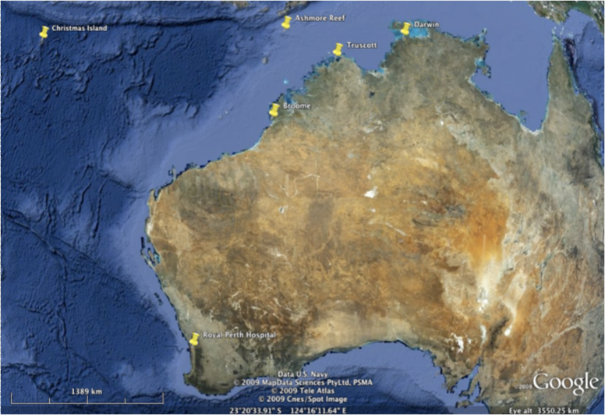

This map shows the vast distance from Ashmore Reef to Royal Perth Hospital. All the 23 victims of the boat explosion survived, despite the difficulties of bringing patients more than 3000kms to medical care.

Blood Service orders now via email from all sites
The Australian Red Cross Blood Service will change over from faxes to emails on 5 September for its Melbourne distribution site.

This change means that all BloodNet orders will be received via encrypted email from that date.

BloodNet users in affected laboratories do not need to do anything differently in the wake of this change. The only noticeable difference is that the fax icons will be replaced by email icons, as shown below:

The order has been sent to the Blood Service, but they have not yet confirmed receipt of the order

The order has been sent to the Blood Service and they have confirmed receipt of the order

The Melbourne site was the last distribution centre to change over from faxed orders.

Recent issues with the fax gateway service used by BloodNet to transmit orders to the Melbourne distribution site have been causing false fax failure messages to be displayed to users. These issues have highlighted the unreliability of the fax service and we look forward to the move to the more reliable, secure and faster email orders.

BloodNet User Reference Group
The next meeting of the BloodNet User Reference Group (BURG) will be held by teleconference on Wednesday, 21 September 2011 between 3pm and 5pm (Eastern Standard Time).

This meeting will be reviewing and prioritising the range of suggested enhancements for BloodNet that have been received in recent months to inform the ongoing development of the system.

If you would like to join BURG, contact BloodNet Support to be added to the mailing list.

Laboratory Information System Interfaces Update
Good progress on interfaces between BloodNet and hospital laboratory information systems (LISs) has been achieved over the last two months with work now underway on two interfaces.

The Steering Committee to oversee this proof of concept trial is now being formed, with the majority of members now appointed. We anticipate that the first meeting of the Committee will be held in late September to guide this important development. Regular updates following meetings of the Steering Committee will be included in this newsletter.

AUSLAB Interface
Work with Queensland Health and the AUSLAB vendor is progressing well with meetings occurring to discuss the requirements for interface.

The enhancement to AUSLAB to implement an interface between AUSLAB (in Queensland Health) and BloodNet is proposed for delivery in June 2012.

e-blood Interface
The funding agreement between NSW Health and the NBA to meet the costs of an interface between BloodNet and e-blood was recently signed and work with the e-blood team at the John Hunter Hospital and their vendor will commence in early September.

ULTRA TM Interface
Work with PathWest on the ULTRA TM interface has slowed in recent weeks due to a range of other pressing commitments on all involved and in light of the delay in the implementation of BloodNet in the PathWest laboratories.
Authorised by Peter O’Halloran,
Chief Information Officer,
National Blood Authority

31 August 2011
Please

