BloodNet Scheduled Outage
BloodNet will be unavailable for use on Saturday 7 April between 1pm and 4pm (AEST) to enable a new version of BloodNet to be implemented.

Fate Module update
The Fate module continues to be rolled out across Australia with implementation now completed in five out of eight States and Territories. Implementation of the module in Queensland is scheduled for May.

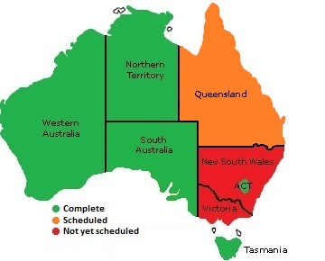

Four reports can now be generated online by laboratories who are already using the Fate module in BloodNet. These are:
- Discard – Blood Components
- Discard – Products
- Transfer – Blood Components
- Transfer – Products
These reports contain the full details of units recorded in BloodNet as discarded, transferred to or from another laboratory.

Further reports will be released through BloodNet in the coming months. These reports will aggregate the raw data available in the current reports to present a high level summary.

BloodNet Revamp
Over the past four months, the BloodNet development team has been quietly revamping the system’s functionality in what is the biggest change to BloodNet (then ORBS) since 2008.

The primary focus of the revamp has been in the Ordering and Receipting modules, however enhancements have been made across the system.

The enhancements will be implemented during the Scheduled Outage on Saturday 7 April (between 1pm and 4pm AEST). A detailed list of changes will be released at that time, however given the intuitive nature of the changes, no retraining for users should be required.

The changes are largely the result of feedback from users and the BloodNet User Reference Group (BURG). Thanks to everyone who has taken time over the last few months to make suggestions that have led to these improvements.

Ordering Module
The most profound changes are in the Ordering Module. These are:
- The four previous order types have been condensed down to two types – Stock Orders and Special Orders. Fresh components and manufactured products may now be ordered on the same order.
- The number of screens to place orders has been reduced from three to two – the Order Entry screen (where all data entry is performed) and the Order Review screen (where you can review the order before placing it with the Blood Service).
- Special Orders can now be copied, enabling laboratories to copy previously placed orders and edit them prior to sending them again to the Blood Service.
- Order priorities of Routine or Urgent can be applied to Stock Orders and priorities of Routine, Urgent and Life Threatening to Special Orders. Pop-up screens provide definitions for each priority for users along with any relevant instructions (such as the need to contact the Blood Service by telephone for any Urgent or Life Threatening orders).
- The individual line items for units on the Order Entry and Order Review screens are now colour-coded to enable ready identification of the different types of units.
- The order in which fresh components appear on the Order Entry screen for Stock Orders can be customised to suit the needs of each laboratory. This order only affects the way that the items appear on the Order Entry screen. The order of items in the orders transmitted to the Blood Service is unchanged.
- The order of manufactured products in the Order Entry screen is now alphabetised.
- With Special Orders, the Date of Birth field is not mandatory if the Gender field option of Unknown is selected. This change should make it easier for those laboratories that place orders for units on a routine basis for unborn babies.
- The fields at the top of both Stock Orders and Special Orders have been amended to streamline the data entry of details such as the date and time required for deliveries.
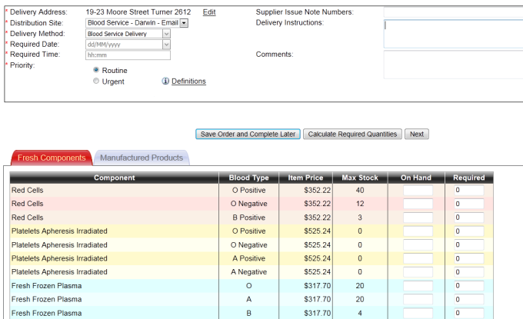

Screenshot of the new Stock Order Entry screen

Receipting Module
Two key changes have been made in the Receipting Module that should decrease the time taken receipting units:
- The list of Issue Notes on the main receipting screen are now colour-coded based on the contents of each Issue Note to enable ready identification of the correct Issue Notes.
The colours are matched to the same standard colours as the packing tape on Blood Service shippers.
- Issue Notes that are deleted by the Blood Service in their National Blood Management System (NBMS) are now marked in BloodNet as Cancelled and they are automatically moved to a separate Cancelled Issue Notes tab.
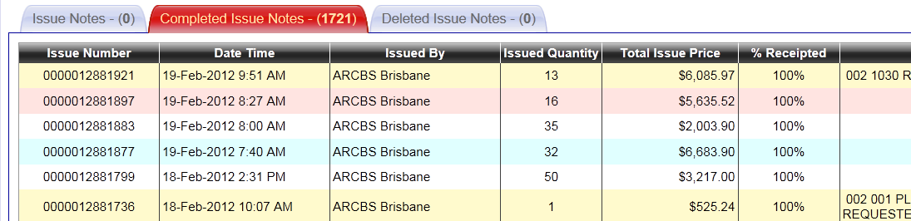

Screenshot of the new Receipting screen illustrating the colour coding of Issue Notes and the new Cancelled Issue Notes tab.

Information Module
The order search functionality has been expanded and users may now search for Special Orders by either the Patient Name or Patient UR Number in addition to the previous search options of Order Number or a Date Range.

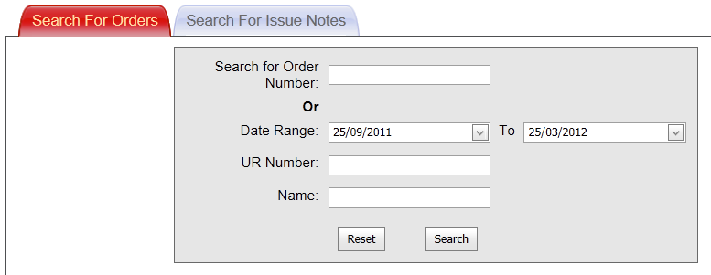

Screenshot of the new Search for Orders screen illustrating the additional search fields of Name and UR Number.

Recently two additional reports for the Fate Module (relating to unit transfers) and an enhanced Feedback Report were made available in the Report menu option with further reports due over the coming months.

Configuration
Administrators from laboratories can now modify the Stock Order templates much quicker with the introduction of the ability to select multiple components or products to add templates, rather than having to select them one at a time.

Sneak Preview
From Monday, 2 April, you can log onto the BloodNet test environment (https://www.blood.gov.au/uat) and see how the new features look and work prior to them going into full production on Saturday 7 April.

BloodNet – LIS Interfaces
Interfaces between BloodNet and Laboratory Information Systems (LIS) has been a focus of considerable effort over the last few months and there have been a number of worthwhile developments.

The specifications for such interfaces have been developed and a draft circulated to a number of LIS vendors for their consideration and input. These specifications will then be further refined and put to the BloodNet – LIS Interface Steering Committee for final endorsement. If you wish to obtain a copy of the draft specification for review and comment, please contact BloodNet Support (contact details at the bottom of the page).

Considerable modification of the BloodNet application has been undertaken to enable it to be able to link into interfaces as they are developed. This work is on-going and is expected to be completed by July 2012.

The NSW Ministry of Health and Pathology North have now finalised their Project Plan for a pilot interface between BloodNet and eBlood. It is anticipated that this interface will be implemented mid-year.

We are also working closely with PathWest in Western Australia and we hope in the coming weeks to implement a partial interface between BloodNet and their LIS. This process will pass the inventory levels between their LIS and BloodNet in an automated manner every 60 minutes and will pre-populate the ‘On-Hand’ column in the Stock Order Entry screen.

A more detailed description of the proposed functionality for such interfaces is in the BloodNet Newsletter of June 2011 which is on the NBA website at www.nba.gov.au/bloodnet .

Meet the BloodNet Development Team
With all of the focus on the on-going development and enhancement of BloodNet in this issue, we thought now would be a good time to introduce our talented team of software developers who maintain and enhance BloodNet on a daily basis.

Left to Right: Daniel Macey, Theo Bogiatzis (front), Paul Havey, Prashant Brall (front) and Andrew Berman.

Daniel Macey – In between managing the development team, Daniel is responsible for planning the migration of BloodNet to new infrastructure (i.e. new servers and associated arrangements) and focussing on interfaces between BloodNet and Laboratory Information Systems in pathology laboratories across Australia.

Andrew Berman – Andrew is responsible for responsible for enhancements to user functionality and the user interface in BloodNet. He is also developing many of the changes that will be implemented in the next version of BloodNet (to be released on 7 April).

Theo Bogiatzis – For the last few months Theo has been working on re-writing the BloodNet services that process Issue Notes and a variety of other essential functions. This work has already greatly improved the robustness of BloodNet.

Prashant Brall – Prashant is a relative newcomer to the team and he is working on the Guard application. This is a central user authentication and management service that we will be implementing in BloodNet and the new Australian Bleeding Disorders Registry (ABDR) in the coming months. The Guard application is
being designed to eventually link into the National E-Health Transition Authority’s (NEHTA) National Authentication Services for Health (NASH).

Paul Havey – Paul has recently joined the BloodNet team and is focussed on the redevelopment of existing BloodNet reports and implementation of new reports over the coming months.

Victorian hospitals continue to switch to BloodNet
Late last year, Victoria’s oldest hospital, the Royal Melbourne Hospital, adopted BloodNet making it the third out of Victoria’s five largest hospitals to move to BloodNet.

Michael Haeusler, Scientist in Charge of the Transfusion and Cryopreservation Labs at the Royal Melbourne, said he liked the functionality and the receipting – and especially that it clearly displayed all orders submitted.

“With faxing, if there wasn’t any paper in the fax machine, you really didn’t know if the order had gone through, but with BloodNet we can tell it’s been ordered,” he said.

Since then, BloodNet has gone live at Austin Health, Cabrini, Peter MacCallum Cancer Centre, the Northern Hospital, PathCare Geelong and Dandenong Hospital.

BloodNet is now processing more than 50% of orders to the Blood Service in Victoria and 65% of orders nationally to the Blood Service.

A number of new laboratories including Monash Medical Centre, Melbourne Pathology, Eastern Health (incorporating Box Hill, Maroondah and Angliss Hospitals) are all going live on BloodNet during April. By then, BloodNet will be processing more than 70% of orders to the Blood Service in Victoria.

Over the coming months, BloodNet will continue to move across regional Victoria with more sites going live each week.

Launch of patient guidelines:
Module 2 Perioperative
The Patient Blood Management Guidelines: Module 2 Perioperative, and the accompanying Quick Reference Guide and Technical Reports are now available from the NBA website at www.nba.gov.au/guidelines/module2 .

The Perioperative Module is intended to inform healthcare practitioners, health educators, health service managers and policy makers about the pre, intra and postoperative care of patients undergoing surgery or invasive procedures, particularly those in whom blood loss is anticipated. Transfusion decisions for patients should take into account each individual’s clinical circumstances and physiological status, and their treatment preferences and choices.

Hard copies of the Perioperative Module and Quick Reference Guide can be ordered free of charge from the NBA website.

National Report on the issue and use of IVIg
The National Report on the issue and use of Intravenous Immunoglobulin (IVIg) for 2010-2011 is now available from the NBA website at www.nba.gov.au/ivig .

Authorised by Peter O’Halloran
Chief Information Officer
National Blood Authority
29 March 2012
Please

