# BloodNet scheduled outage

**BloodNet will be unavailable from 00:01 AEDT on Saturday, 3 November 2012 until 00:01 AEDT on Sunday, 4 November 2012.** During this outage, the hosting infrastructure for BloodNet will be moved to a new data centre, further increasing the resilience of the system.

Where possible, please place your orders before or after this scheduled outage. If you need to place any orders during the outage, please place them with your local Blood Service distribution centre directly by fax using the Manual Routine Order Forms that you should download from BloodNet (Configuration 🡪 Facility Order Template) prior to the outage.

BloodChat Image

One of the exciting new developments the National Blood Authority will be demonstrating at the HAA 2012 Conference in Melbourne will be the newly launched BloodChat application.

BloodChat is a group of online discussion forums that enable those working or interested in the blood sector to come together virtually to share ideas, resources and to discuss matters relating to transfusion.

Peter O’Halloran, A/g Deputy General Manager Stewardship with the National Blood Authority said “There are so many great ideas and highly successful transfusion programs around Australia, but a real lack of suitable means of sharing and celebrating these great initiatives. BloodChat will fill this void and enable those working in transfusion to share ideas, questions and successes with their peers across the country.”

Access to BloodChat is only three simple steps away – see <http://www.nba.gov.au/bloodchat> for further information and to create an account today.

# BloodNet now processing over 90% of orders nationally

The ongoing national implementation of BloodNet continues, with BloodNet now processing over 90% of orders (by volume of total units) placed against the Blood Service.

The transition from the Blood Service’s legacy system, ERIC, continues with the implementation of the BloodNet Fate module (recording unit discards and transfers) gaining pace, with the Fate module now implemented across two-thirds of health providers across Australia.

If you have not yet implemented the Fate module in your laboratory, contact the Blood Systems Support team on 13 000 BLOOD, or email [BloodNet@nba.gov.au](mailto:BloodNet@nba.gov.au), to arrange training sessions.

# Blood Systems Support Operations Centre opens

The Blood Systems Support Operations Centre opened in August, providing the Blood Systems Support team that support BloodNet and a growing list of applications with an enhanced ability to support these critical systems.

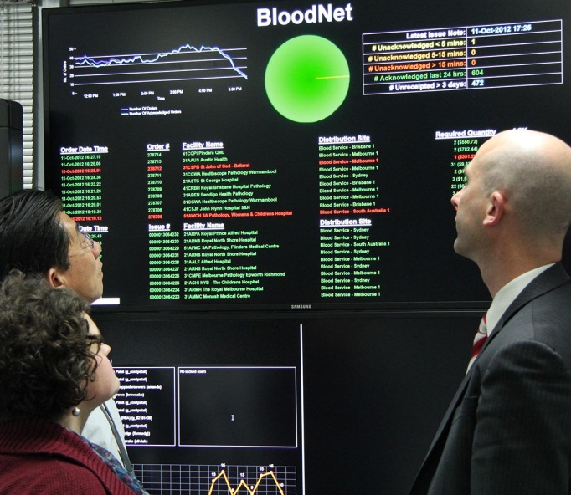

Left to right: Peter Goh, Rebecca Heland and Nathan Kruger inspect one of the nine displays in the Blood Systems Support Operations Centre.

Rebecca Heland, Manager of Blood Systems Support said “The Operations Centre has changed how we support BloodNet and our other systems. Now we can proactively monitor and respond to issues before they become problems and impact on health providers.”

The Operations Room faced its first test days after opening when the Blood Service email system (that is used to receive orders from BloodNet and populate BloodNet with Issue Notes) experienced a twelve hour outage in early September.

The Blood Systems Support team swung into action, using the Operations Room to track progress on resolution of the issue and to coordinate the communication and contingency arrangements with BloodNet moving back to faxed orders until the Blood Service were able to resolve their technical issues.

“We used the technology in the Operations Centre to notify all health providers of the issue and to coordinate the contingency arrangements in BloodNet. The Operations Centre enabled us to monitor changes minute by minute and the enhanced visibility of key indicators enabled us to transition back to normal ordering arrangements at least two hours faster than we would have been able to before the commissioning of the Operations Centre” said Rebecca.

# Online training sessions

Don’t forget that online training sessions for new users or those in need of a refresher are available and the Blood Systems Support team are happy to conduct one on one training sessions using web-conferencing at times that suit your staff.

Call 13 000 BLOOD (13 000 25663) to arrange a training session.

# Reporting

Over the past six months, the BloodNet development team have been re-writing much of the code behind BloodNet to enable it to interface successfully with health provider Laboratory Information Systems (LISs) as part of our interface trial.

This work has reduced the development effort on enhanced BloodNet reports and as work on the recoding of BloodNet for interfaces decreases in the coming weeks, the development team will focus once again on reports.

We have a range of reports under development which the developers will be working up over the coming weeks to be presented to the next meeting of the BloodNet User Reference Group (BURG) for their consideration.

If you have any views on the reports, or what you would like to see in future reports, please email your ideas to [BloodNet@nba.gov.au](mailto:BloodNet@nba.gov.au) so they can be incorporated into the planning now underway.

# BloodNet User Reference Group

Tell us what you think by getting involved in the BURG. New members are always welcome and you can nominate yourself for membership at any time by emailing the support team ([BloodNet@nba.gov.au](mailto:BloodNet@nba.gov.au)).

Since its formation, this group has helped shape many of the changes and upgrades to BloodNet that are now underway, from LIS interfaces to reporting.

You don’t need to travel to be part of this group, as meetings are done via teleconference from participants located all over Australia.

The meeting schedule for 2013 has now been set, and now is the time to nominate and put these meetings in your diary:

* 14 February 2013 (1500-1600 AEDT)
* 9 May 2013 (1500-1600 AEST)
* 8 August 2013 (1500-1600 AEST)
* 14 November 2013 (1500-1600 AEDT)

Notes from the recent meeting of BURG will be included in the November 2012 BloodNet Newsletter.

# Receipting components with the same donation number

Occasionally, you will receive multiple components with the same donation number on a single issue note as illustrated below.

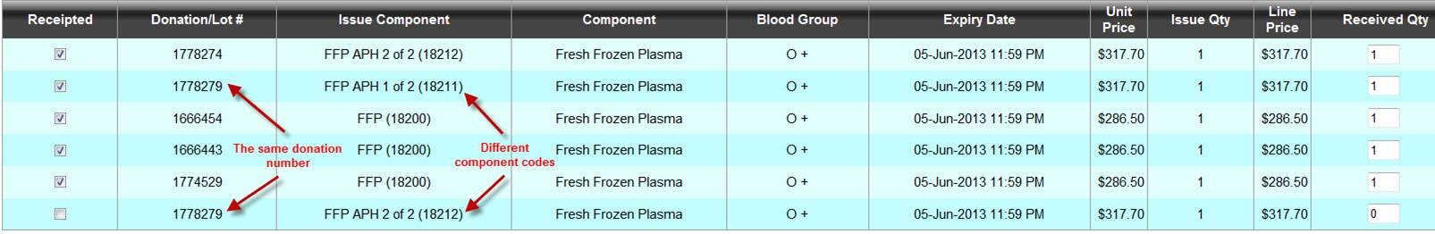

Scan in the donation number as you normally would.

You might receive this box immediately:

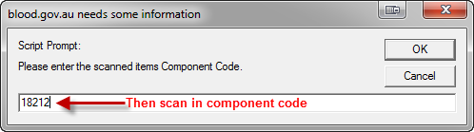

Once you scan the component code it will receipt the component.

If you don’t receive the box it could be because you need to click on a highlighted area at the top of the tool bar to allow the pop-up and then continue:

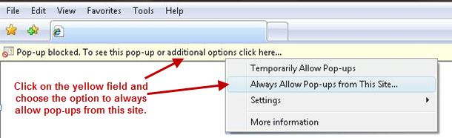

# Receipting manufactured batch products

Manufactured batch products are issued by the Blood Service in a manner that is different to the manner in which they issue fresh components. One obvious indicator of this is that manufactured batch products will appear on an issue note with multiple units listed on a single line (with a quantity greater than one).

To receipt such units correctly, you need to undertake the following three steps:

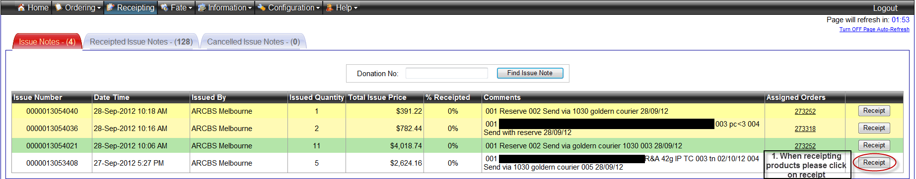

1. Select the Issue Note from the main receipting screen in the normal manner.

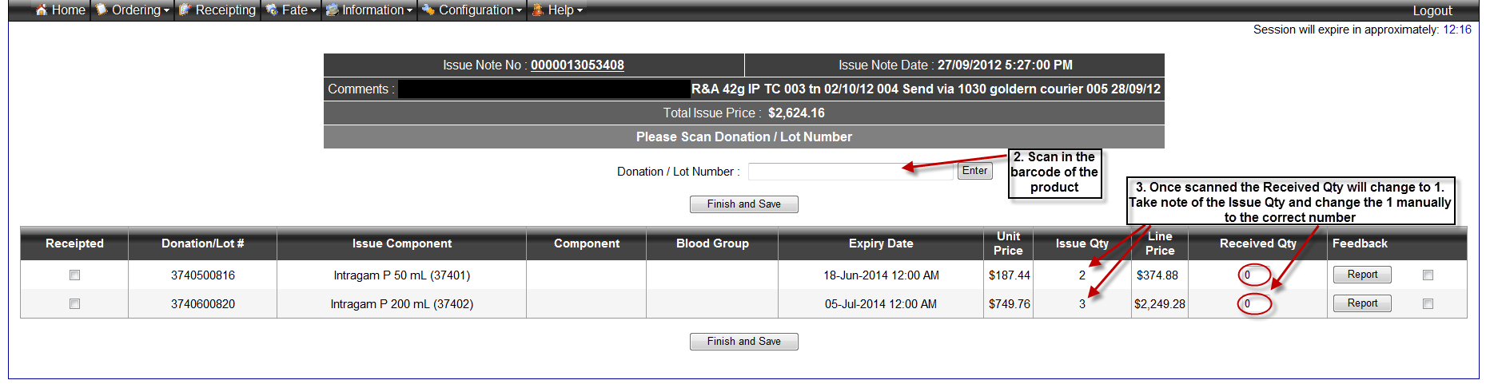

1. Scan the unit barcode
2. Once you have scanned the unit barcode, the Received Quantity column will change to 1. Once you have counted the physical units, you can either change the received quantity on the keyboard to the correct number, or scan each unit which will increment the quantity by 1 for each unit scanned.

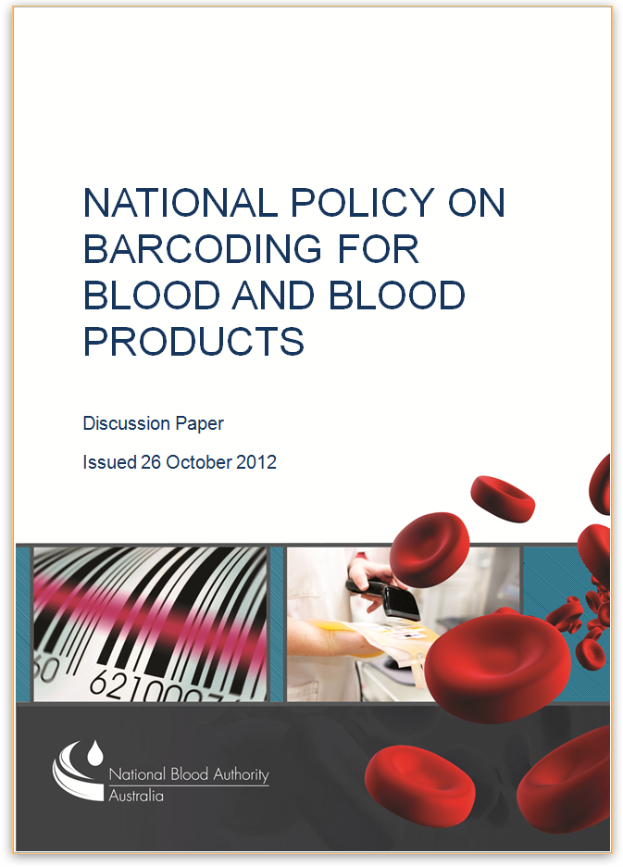

# Barcoding policy

A discussion paper on the National Policy on Barcoding for Blood and Blood Products was released by the NBA earlier today. The discussion paper proposes a number of changes to how barcodes will be applied to blood and blood products.

Please take a moment to read the paper and provide feedback to the NBA (details in the paper).

Authorised by Peter O’Halloran  
A/g Deputy General Manager, Stewardship  
 National Blood Authority

26 October 2012

Please