Obtaining Fridge Compliance

When can I create a Blood Fridge?
A Blood Fridge can be registered in BloodNet for any fridges associated with your facility, even offsite fridges or fridges external to the lab. You can also link to a fridge your facility receives products from, in order to monitor the conditions that your products were stored in prior to transfer to you.

Creating a Fridge in BloodNet
- From the BloodNet home page, go to Fridges > Fridge Management.
- Select Add New Fridge. The following dialogue box will pop up:
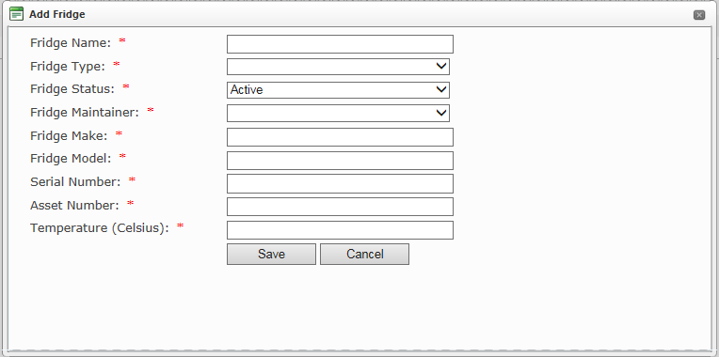
- Enter the details of your fridge and hit enter. You will then need to create a maintenance plan and record to obtain fridge compliance.

Creating a maintenance plan
- Click on the fridge you want to make a plan for.
- Select Maintenance Plan > Create Maintenance Plan
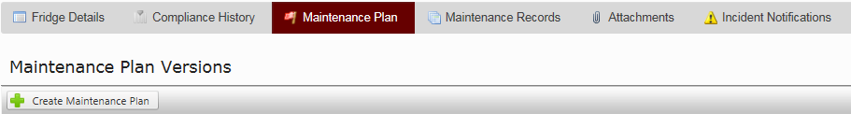

Creating a maintenance record
- Create a new maintenance plan for a fridge. Select “Add Maintenance Record” and select the fridge the record is for. The checks can then be customised.
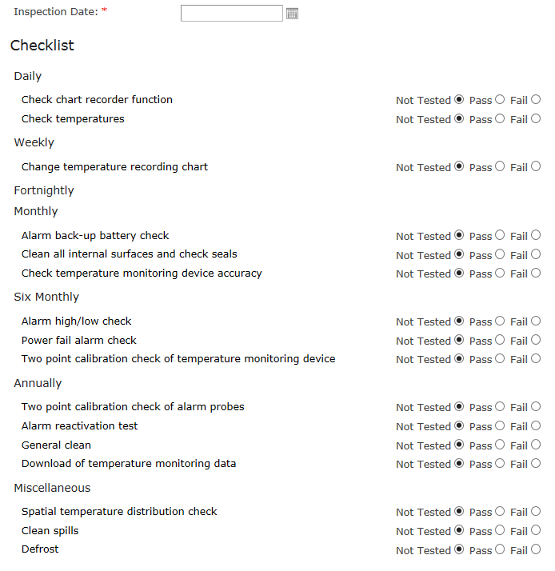
Note: If your checklist is not actioned within 7 days, the fridge will automatically become noncompliant.

Backdating a maintenance record to obtain compliance

Why backdate a maintenance record?
Backdating a maintenance record not only allows you to maintain continuity with your previous fridge records, it also allows you to achieve fridge compliance on BloodNet by establishing that you have undergone previous checks before entering the fridge into our system.

How to backdate
- To obtain compliance and manage calendar re-occurrences of maintenance records effectively, users will need to enter historical maintenance records.
Note: You cannot backdate a maintenance plan. If an existing Maintenance Plan has Maintenance Records attached it cannot be Edited - Instead create a new Maintenance Plan.
- Once this is done, go to Maintenance Records and select “Add Maintenance Record”.
Note: if this option does not appear, create a new maintenance plan. This should resolve the issue.

- Once a maintenance record has been added, it can be backdated, which is handy for infrequent tests e.g. Annual - Alarm reactivation test. Note: users may need to enter multiple backdated maintenance records if the historical tests occurred on different days.

