Print Fridge Checksheet
It is possible to generate a printable fridge checksheet for any fridges registered in your BloodNet facility with an attached maintenance plan. These checksheets are automatically customised by what options for maintenance are disabled or enabled for each of your fridges and the individual maintenance plans.
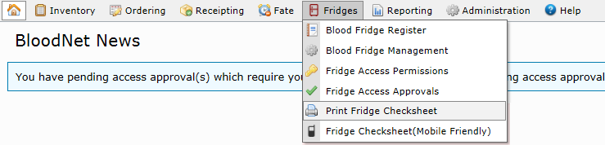
- Under Fridges, select Print Fridge Checksheet.
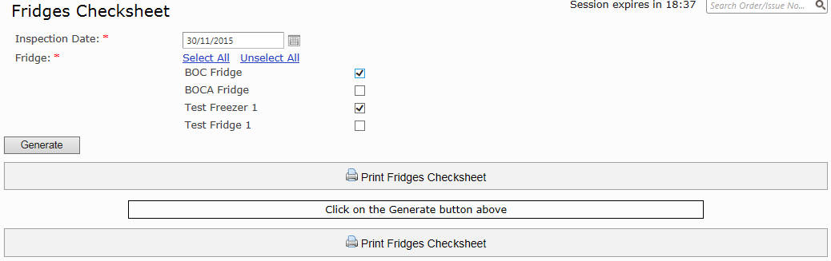
- On the Fridges Checksheet page, choose the Inspection Date and which of your fridges or freezers you would like to generate a checksheet for.

- Click Generate. This will create a checksheet for each fridge or freezer you have selected, separated by headings.
- Once your checklist(s) have been generated, click Print Fridges Checklist.

