Shared Inventory Search
Once other facilities have shared their inventory data with you, it then becomes possible to do a Shared Inventory Search. This search is useful when trying to find desired units at linked facilities for quick transfers and better inventory management.
- Hover over Inventory and select Shared Inventory Search.
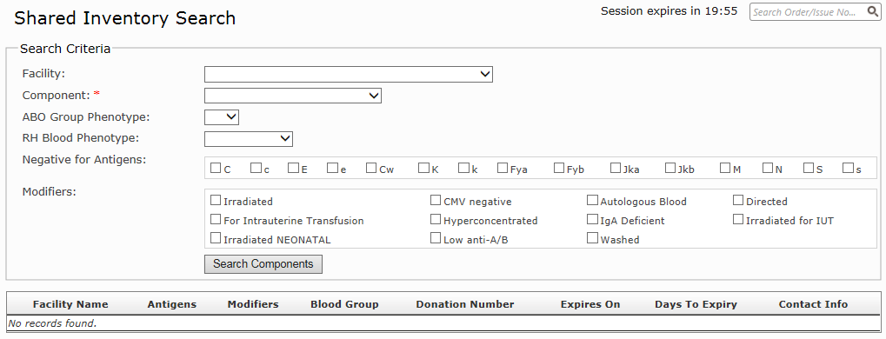
- The only mandatory field on the search page is the Component field, marked with an asterisk. All other fields are optional, but will further refine the search. Enter your requirements and click Search Components.

- From the search results you will see any matching units within the search parameters given. Details listed include antigens, modifiers, blood group and donation number, as well as the expiry. The contact details of the facility to whom the unit belongs are also displayed, in case you would like to request they transfer the unit to you.

