SINGLE UNIT TRANSFUSION GUIDE SUMMARY
JUNE 2014
Guidance for Australian Health Providers
Version | Date | Change | Planned Review
1 | September 2013 | Initial Document
1.1 | June 2014 | Reviewed and further information provided on chronically transfused patients.  Insertion of Creative commons and ISBN. | June 2016

© National Blood Authority, 2014.
With the exception of any logos and registered trademarks, and where otherwise noted, all material presented in this document is provided under a Creative Commons Attribution-NonCommercial- ShareAlike 3.0 Australia licence (https://creativecommons.org/licenses/by-nc-sa/3.0/au/).

You are free to copy, communicate and adapt the work for noncommercial purposes, as long as you attribute the authors and distribute any derivative work (i.e. new work based on this work) only under this licence.
If you adapt this work in any way or include it in a collection, and publish, distribute or otherwise disseminate that adaptation or collection to the public, it should be attributed in the following way:

© National Blood Authority, 2014.

ISBN 0-9873687-4-5

For more information:

Single Unit Transfusion Guide Summary
National Blood Authority
Locked Bag 8430
Canberra ACT 2601
Phone: 13000BLOOD (13 000 25663)
Email: patientbloodmanagement@.blood.gov.au
Website: www.blood.gov.au

Disclaimer

This document is a general guide to appropriate practice, to be followed subject to the circumstances, clinician’s judgement and patient’s preferences in each individual case. It is designed to provide information to assist decision making. Recommendations contained herein are based on the best available evidence published between 1966 and up to July 2010. The relevance and appropriateness of the information and recommendations in this document depend on the individual circumstances. Moreover, the recommendations and guidelines are subject to change over time.

Each of the parties involved in developing this document expressly disclaims and accepts no responsibility for any undesirable consequences arising from relying on the information or recommendations contained herein.

Table of Contents
Why have a single unit transfusion guide? 4
Which health care professionals should use this guide? 4
Key Principles: 5
What are the indications for transfusion in patients who are not actively bleeding? 6
Red blood cell transfusion in chronically transfused patients. 7
Iron Deficiency Anaemia. 7
Why does transfusion practice need to change? 8
Resources 9
Acknowledgements 9
Reference List 10
Appendix 1: Example Clinical Guideline 11
Appendix 2: Considerations and guidance for implementation of single unit transfusion 23
Appendix 3: Example Handout Summary for a Single Unit Policy 32

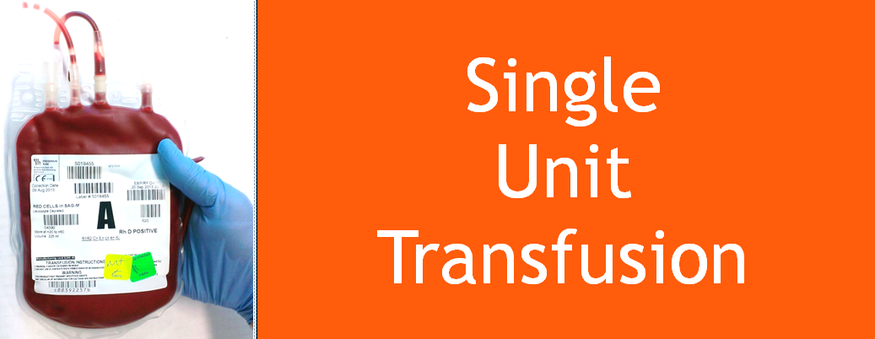

Why have a single unit transfusion guide?
Every ONE matters”
This guide aims to improve clinical practice and patient outcomes through alignment with the Patient Blood Management Guidelines.^{1–3} It is intended for use by all clinicians responsible for prescribing red blood cell transfusion. The single unit transfusion guide can be applied to stable, normovolaemic adult patients, in an inpatient setting, who do not have clinically significant bleeding.⁴
To ensure action is taken to increase patient safety, reduce the risks of patient harm and to reduce the risks associated with transfusion practices and the clinical use of blood and blood products.
Reminder: This guide does not apply to the patient with clinically significant bleeding.⁴ There may be other patients to whom this policy does not apply, as assessed by the treating clinician.

Which health care professionals should use this guide?
- Clinicians responsible for the clinical assessment, care planning and management of patients potentially requiring red blood cell transfusion therapy.
- Nurses carrying out transfusion related patient care including administration and monitoring of red blood cell transfusions.
- Laboratory staff monitoring transfusion policies.

Key Principles:
Informed consent must be obtained from the patient or responsible person/guardian.
Ensure the safety and efficacy of red blood cell transfusion by confirming every unit transfused is a clinical decision where the expected benefit outweighs the risks.
Each red blood cell transfusion should be an independent clinical decision based on the risk, benefits and alternatives. Where indicated, transfuse a single unit of red blood cells, then clinically reassess the patient to determine if further transfusion is required. Transfusion should not be based on haemoglobin level alone but should also be based on assessment of the patient’s clinical status.^{1,3} For haemoglobin thresholds refer to the national Patient Blood Management Guidelines, Module 3 – Medical practice point 3 (PP3) and Module 4 – Critical Care practice point 4 (PP4).
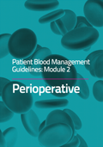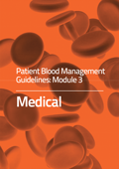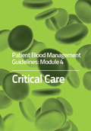
Transfuse one unit at a time and only when clinically indicated, based on the need to relieve clinical signs and symptoms of anaemia.^{1,3} Symptoms may include dyspnoea, tachycardia, chest pain, hypotension, increased heart rate and decreased oxygen saturation.^{5–7}
Single unit red blood cell transfusion reduces the patient’s exposure to allogeneic blood.^{8,9}
Transfusion is a live tissue transplant and not without associated risks.
Optimising patient tolerance of anaemia is one of the three pillars of patient blood
management.^{1–3}
Consider early haematological advice about anaemia management.

Risks associated with transfusion are dose dependent:^{10,11}
Red blood cell transfusion may be associated with a dose-dependent increased risk of nosocomial infection and other morbidities.^{10,11} For further information on transfusion risks see Appendix B of the national Patient Blood Management Guidelines.1–3
If one unit has achieved the stated outcome for the red blood cell transfusion, for example improvement in clinical signs and symptoms of anaemia, further units will only increase the risks.

What are the indications for transfusion in patients who are not actively bleeding?
In accordance with the national Patient Blood Management Guidelines:^{1–3}

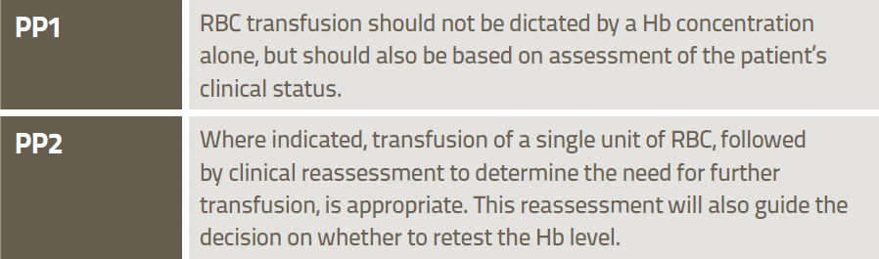
Patient Blood Management Guidelines: Module 3 - Medical1

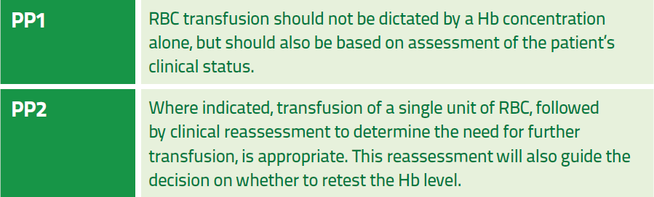
Patient Blood Management Guidelines: Module 4 – Critical Care3
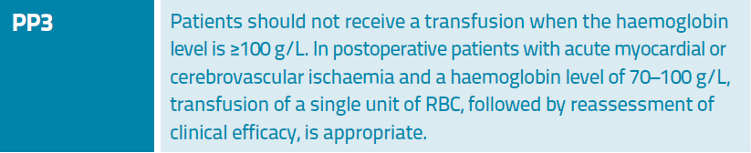
Patient Blood Management Guidelines: Module 2 - Perioperative2

Red blood cell transfusion in chronically transfused patients.
Chronically transfused patients are usually managed as outpatients. Hence, for practical reasons, they are often prescribed a predetermined number of RBC units (intended to achieve a defined Hb concentration), rather than having their response assessed after each unit. In addition, these patients may be deliberately transfused to a higher level of Hb than is physiologically necessary, in an attempt to maximise the interval between transfusions.
For patients who are chronically transfused please refer to the relevant practice points in the Patient Blood Management Guidelines: Module 3 – Medical:¹
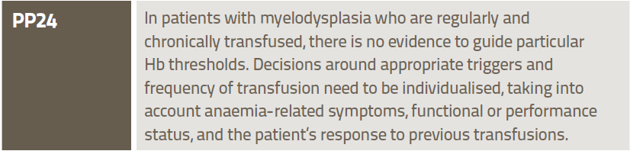
Patient Blood Management Guidelines: Module 3 - Medical¹

Iron Deficiency Anaemia.
Red cell transfusion is inappropriate therapy for iron deficiency anaemia (IDA) unless an immediate increase in oxygen delivery is required, such as when the patient is experiencing end-organ compromise (e.g. angina pectoris or cardiac failure), or IDA is complicated by serious, acute ongoing bleeding. Oral iron therapy, in appropriate doses and for a sufficient duration, is an effective first-line strategy for most patients. In selected patients for whom intravenous (IV) iron therapy is indicated, current formulations can be safely administered in outpatient treatment centres and are relatively inexpensive.¹²
The Patient Blood Management Guidelines: Module 3 – Medical¹ state:
Patient Blood Management Guidelines: Module 3 - Medical¹

All patients who receive one unit of red blood cells should be reassessed to determine their need for further transfusion therapy with red blood cell units. The decision to prescribe subsequent units should be based on the same parameters and clinical indications as those considered for the initial order.

Why does transfusion practice need to change?
It is important to ensure that practice aligns with the national Patient Blood Management Guidelines (Module 2 – Perioperative, Module 3 - Medical and Module 4 - Critical Care) that support a single unit transfusion.
Historically, two unit red blood cell transfusions were common practice as a single unit was not considered sufficient to correct anaemia.^{8,9} Single unit transfusions currently represent only a small proportion of all transfusion.
Red blood cell transfusion also poses on going challenges in balancing supply and demand due to the increasing age of the population: demand for blood will increase but the available donor pool will decrease.
Although the blood supply in Australia is extremely safe from the currently known infectious agents, the potential threat from as yet unknown, or re-emerging pathogens deserves cautious consideration.¹³
The National Safety and Quality Health Service Standard 7: Blood and Blood Products requires blood and blood product policies and procedures to be consistent with national evidence based guidelines for pre-transfusion practices, prescribing and clinical use of blood and blood products.¹⁴
- 7.1.1 Blood & blood product policies, procedures and/or protocols are consistent with national evidence based guidelines for pre-transfusion practices, prescribing & clinical use of blood & blood products
- 7.1.3 Action is taken to increase the safety & appropriateness of prescribing & clinically using blood & blood products
- 7.2.2 Action is taken to reduce the risks associated with transfusion practices & the clinical use of blood and blood products
- 7.4.1 Quality improvement activities are undertaken to reduce the risks of patient harm from transfusion practices & the clinical use of blood & blood products. Resources to support Single Unit Transfusion

Resources
The following resources may assist with the implementation of a Single Unit Transfusion guideline. The resources listed below and example PowerPoint presentation, newsletter and posters are also available from the http://www.blood.gov.au/single-unit-transfusion page on the NBA website in word format, to allow alteration to suit local requirements.

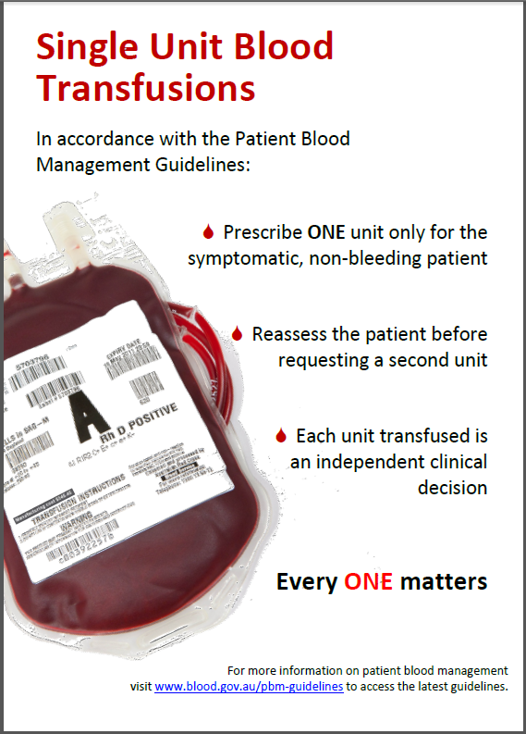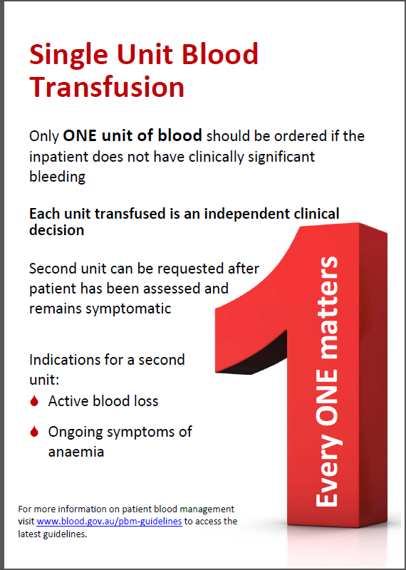
Example Clinical Guideline Format - Appendix 1:
This is an example of the information presented in a Clinical Guideline Format that can be adapted to your local Clinical Guideline. It is recognised that clinical guideline formats vary nationally; this format is representative of one local health network.
Consideration and Guidance for Implementation - Appendix 2:
To present to the hospital Transfusion Governance Committee / Patient Blood Management Committee seeking agreement to the guideline and details of how it would be implemented.
Example Handout Summary - Appendix 3:
A one page summary of Single Unit Transfusion information that can be used as a handout.

Acknowledgements
The National Blood Authority extends their appreciation to Hunter Area Pathology Service and
Pathology North, for their involvement in the development of this guide.

In particular the National Blood Authority would like to acknowledge the contribution and expertise of Ms Vicki Martens, Senior Hospital Scientist, Hunter Area Pathology Service.

Reference List
1. National Blood Authority Patient blood management guidelines: Module 3 – Medical. (National Blood Authority: Canberra, Australia, 2012).at <http://www.blood.gov.au/pbm-guidelines>
2. National Blood Authority Patient blood management guidelines: Module 2 – Perioperative. (Canberra, Australia, 2012).at <http://www.blood.gov.au/pbm-guidelines >
3. National Blood Authority Patient blood management guidelines: Module 4 – Critical Care. (Canberra, Australia, 2013).at <http://www.blood.gov.au/pbm-guidelines>
4. Webert, K. E. et al. A new tool to assess bleeding severity in patients with chemotherapy-induced thrmbocytopaenia. Transfusion Practice 52, 2466–2474 (2012).
5. Carson, J. L. Red blood cell transfusion: a clinical practice guideline from the AABB. Annals of Internal Medicine 157, 49–58 (2012).
6. Rossi, E. C. Anaemia and Red cell Transfusion. Principles of Transfusion Medicine, Second edition 1, (1996).
7. Shander, A. A new perspective on best transfusion practices. Review Blood Transfus 1, (2012).
8. Ma, M., Eckert, K., Ralley, F. & Chin-Yee, I. A retrospective study evaluating single-unit red blood cell transfusions in reducing allogeneic blood exposure. Transfusion Medicine 15, 307–312 (2005).
9. Berger, M. D. et al. Significant reduction of red blood cell transfusion requirements by changing from a double-unit to a single-unit transfusion policy in patients receiving intensive chemotherapy or stem cell transplantation. haematologica 97, 116–122 (2012).
10. Koch CG Duncan AI et al, L. L. Morbidity and mortality risk associated with red blood cell and blood-component transfusion in isolated coronary artery bypass grafting. Crit Care Med 2006 34, 1608–1616 (2006).
11. Hajjar LA Vincent JL et al. Transfusion requirements after cardiac surgery: the TRACS randomised controlled trial. JAMA - Journal of the American Medical Association 304, 304:1559–1567
12. Pasricha, S.-R. et al. Diagnosis and management of iron deficiency anaemia: a clinical update. Med J Aust 198, 525–532 (2010).
13. Hofmann, A., Farmer, S. & Shander, A. Five drivers shifting the paradigm from product-focused transfusion practice to patient blood management. The oncologist 16 Suppl 3, 3–11 (2011).
14. Australian Commission on Safety and Quality in Healthcare Safety and Quality Improvement Guide Standard 7: Blood and Blood Products. ACSQHC (2012).at <http://www.safetyandquality.gov.au/wp-content/uploads/2012/10/Standard7_Oct_2012_WEB.pdf>

Appendix 1: Example Clinical Guideline

Disclaimer: This has been adapted from the Hunter New England Local Health District¹ template and is designed as a guide only. It is intended that local guideline templates are used.

Clinical Guideline | [Insert local health network or hospital name / logo]
Single Unit Blood Transfusion Clinical Guideline
Document Registration Number: Insert
Sites where Clinical Guideline applies | All hospitals within [insert local health network or hospital name] where red blood cell transfusions are administered.
This Clinical Guideline applies to: | Adults
Target audience | All medical officers, nursing / midwifery staff and transfusion laboratory staff
Description | This guideline is intended for use by all clinicians responsible for prescribing red blood cell transfusion. The single unit transfusion guideline can be applied to stable, normovolaemic adult patients, in an inpatient setting, who do not have clinically significant bleeding.²  The guideline is consistent with the national Patient Blood Management Guidelines.^{3–5}
Keywords | Single unit, blood, transfusion, non-bleeding, normovolaemic, patient, symptoms.
Related jurisdictional legislation, Australian Standards, National Safety and Quality Health Service Standard , Professional Guidelines, Codes of Practice or Ethics:
- National Blood Authority Patient Blood Management Guidelines: Modules 2-4 http://www.blood.gov.au/pbm-guidelines.
- National Safety and Quality Health Service Standard 7: Blood and Blood Products http://www.safetyandquality.gov.au/wp-content/uploads/2012/10/Standard7_Oct_2012_WEB.pdf.
- ANZSBT/RCNA Guidelines for the Administration of Blood Products Page 14 Section 1; Page 21 Recommendation 9
- [list as appropriate]

TABLE OF CONTENTS (This is a guide only)
Guideline Summary | Page
Glossary | Page
Guideline | Page
Implementation Guide | Page
Evaluation Plan | Page
References | Page
Appendixes | Page
GUIDELINE SUMMARY
This document establishes best practice for [insert local health network or hospital name]. While not requiring mandatory compliance, staff must have sound reasons for not implementing standards or practices set out within the guideline, or for measuring consistent variance in practice.
INTRODUCTION
The Single Unit Transfusion Guideline is part of Patient Blood Management (PBM); an evidence based patient centred strategy to improve patient outcomes by minimising blood transfusions.
The Single Unit Transfusion Guideline can be applied to stable, normovolaemic adult patients, in an inpatient setting, who do not have clinically significant bleeding.^{2,6,7} Transfuse one red blood cell unit at a time and only when clinically indicated, based on the need to relieve clinical signs and symptoms of anaemia.^{4,5}
Ensure clinical practice is in line with the national Patient Blood Management Guidelines:^{3–5} “Where indicated, transfusion of a single unit of RBC, followed by clinical reassessment to determine the need for further transfusion, is appropriate.”^{4,5}
GLOSSARY
Acronym or Term | Definition
NBA | National Blood Authority
ARCBS | Australian Red Cross Blood Service – “The Blood Service”.
NSQHS | National Safety and Quality Health Service
PBM | patient blood management
unit | single bag of red blood cells
TACO | transfusion associated circulatory overload
Hb | haemoglobin
g/L | grams per litre
BloodNet | National Blood Authority inventory management system
CPOE | computerised physician order entry
RBC | red blood cell

GUIDELINE
AIM:
To improve clinical practice and patient outcomes through alignment with the Patient Blood Management Guidelines.^{3–5}
To ensure the safety and efficacy of red blood cell transfusion by confirming every unit transfused is a clinical decision where the expected benefit outweighs the risks.
WHO:
This guideline applies to stable, normovolaemic adult patients, in an inpatient setting, who do not have clinically significant bleeding.²
Health care clinicians responsible for the clinical assessment, care planning and management of patients potentially requiring red blood cell transfusion therapy, nurses carrying out transfusion related patient care including administration and monitoring of red blood cell transfusions and laboratory staff monitoring transfusion practice should follow this guideline.
WHAT:
Informed consent must be obtained from the patient or responsible person/guardian.
Each red blood cell transfusion should be an independent clinical decision based on the risk, benefits and alternatives.
Transfusion should not be based on haemoglobin level alone but should also be based on assessment of the patient’s clinical status.^{4,5} For haemoglobin thresholds, refer to the national Patient Blood Management Guidelines, Module 3 – Medical practice point 3 (PP3) and Module 4 – Critical Care practice point 4 (PP4).
Transfuse one unit at a time and only when clinically indicated, based on the need to relieve clinical signs and symptoms of anaemia.^{4,5} Symptoms may include dyspnoea, tachycardia, chest pain, hypotension, increased heart rate and decreased oxygen saturation.^{8–10}
WHY:
Transfusing single units of red blood cells may reduce a patient’s exposure to allogeneic blood.^{6,7}
Transfusion is a live tissue transplant and not without associated risks.
Optimising patient tolerance of anaemia is one of the three pillars of patient blood management.^{3–5,11}
Risks associated with transfusion are dose dependent:
- Red blood cell transfusion may be associated with a dose-dependent increased risk of nosocomial infection and other morbidities.^{12,13} For further information on transfusion risks see Appendix B of the national Patient Blood Management Guidelines.^{3–5,11}
- If one unit has achieved the stated outcome for the transfusion, for example improvement in clinical signs and symptoms of anaemia, further units will only increase the risks.
It is important to ensure that practice aligns with the national Patient Blood Management Guidelines (Module 2 – Perioperative, Module 3 - Medical and Module 4 - Critical Care) that support single unit transfusion.

The National Safety and Quality Health Service Standard 7: Blood and Blood Products requires blood and blood product policies and procedures to be consistent with national evidence based guidelines for pre-transfusion practices, prescribing and clinical use of blood and blood products.¹⁴
- 7.1.1 Blood & blood product policies, procedures and/or protocols are consistent with national evidence based guidelines for pre-transfusion practices, prescribing & clinical use of blood & blood products
- 7.1.3 Action is taken to increase the safety & appropriateness of prescribing & clinically using blood & blood products
- 7.2.2 Action is taken to reduce the risks associated with transfusion practices & the clinical use of blood and blood products
- 7.4.1 Quality improvement activities are undertaken to reduce the risks of patient harm from transfusion practices & the clinical use of blood & blood products
Single unit transfusions are appropriate in stable adult patients, in an inpatient setting, who do not have clinically significant bleeding and may reduce transfusion associated morbidity and mortality.^{8,15}
Historically, two unit red blood cell transfusions were common practice as a single unit was not considered sufficient to correct anaemia.^{6,7} Single unit transfusions currently represent only a small proportion of all transfusion.
Red blood cell transfusion also poses ongoing challenges in balancing supply and demand due to the increasing age of the population. Demand for blood will increase but the available donor pool will decrease.
Although blood is extremely safe from the currently known infectious agents, the potential threat from as yet unknown, or re-emerging pathogens deserves cautious consideration.¹⁶
HOW:
These are the indications for red blood cell transfusion in stable, normovolaemic adult patients, in an inpatient setting, who do not have clinically significant bleeding:²
- Clinically assess the patient for symptoms of anaemia such as dyspnoea, tachycardia, chest pain, hypotension, increased heart rate and decreased oxygen saturation.^{8–10}
- “Red blood cell transfusion should not be dictated by haemoglobin concentration alone, but should also be based on assessment of the patient’s clinical status.”^{4,5} For haemoglobin thresholds refer to the national Patient Blood Management Guidelines, Module 3 – Medical practice point 3 (PP3) and Module 4 – Critical Care practice point 4 (PP4).
- “Where indicated, transfusion of a single unit of RBC, followed by clinical reassessment to determine the need for further transfusion, is appropriate.”^{4,5}

For patients who are chronically transfused please refer to the relevant practice points in the Patient Blood Management Guidelines: Module 3 – Medical:⁴ “In patients with myelodysplasia who are regularly and chronically transfused, there is no evidence to guide particular Hb thresholds. Decisions around appropriate triggers and frequency of transfusion need to be individualised, taking into account anaemia-related symptoms, functional or performance status, and the patient’s response to previous transfusions.”
Red blood cell transfusion is inappropriate therapy for iron deficiency anaemia (IDA) unless an immediate increase in oxygen delivery is required, such as when the patient is experiencing end-organ compromise (for example, angina pectoris or cardiac failure), or IDA is complicated by serious, acute ongoing bleeding. Oral iron therapy, in appropriate doses and for a sufficient duration, is an effective first-line strategy for most patients. In selected patients for whom intravenous (IV) iron therapy is indicated, current formulations can be safely administered in outpatient treatment centres and are relatively inexpensive.¹⁷
The national Patient Blood Management Guidelines: Module 3 – Medical⁴ state “In patients with iron deficiency anaemia, iron therapy is required to replenish iron stores regardless of whether a transfusion is indicated.”
IMPLEMENTATION PLAN
The following stepped approach may assist with the implementation of this guideline.¹⁸
- Gain approval or endorsement of the guideline from the following:
- Transfusion Governance Committee / Patient Blood Management Committee
- Executive and Quality managers
- Relevant clinicians
- Transfusion medicine staff
- Identify key staff / team responsible for implementing the guideline
- Identify key staff
- Document the roles and responsibilities of the staff
- Provide education
  - Individual medical specialities
  - All staff, including: medical; nursing; transfusion medicine and wards areas that may or may not use blood
  - Consumer education
  - Education of new staff at orientation
- Key messages
Placement of key messages in the following areas:
- Hospital Intranets, websites
- Transfusion laboratory reports
- Internal hospital newsletters, magazines
- Visible signage of key messages e.g. posters
- Support staff to implement the guideline
  - The Single Unit Transfusion Guideline should be available to all staff.
  - Provide prompts for staff to determine the reason for transfusion e.g. questions to ask such as “Is the patient actively bleeding? Has the patient been reassessed since last transfusion? Is the patient still symptomatic?
  - If a patient does not fall within the criteria, staff should have access to further advice e.g. haematologist, identified medical staff or laboratory director for approval.
The following resources could assist with the implementation of the Single Unit Transfusion Guideline:
- Standard material to present to the hospital Transfusion Governance Committee / Patient Blood Management Committee seeking agreement to the guideline and details of how it would be implemented.
- Education material tailored for:
  - Consumers: For example, iTransfuse Fact Sheet, all about blood, I need to know about Patient Blood Management and Single Unit Red Blood Cell Transfusion^{19,20}
  - Staff:
    - PowerPoint presentation
    - Handout of information
    - Newsletter
- Visible signage
Reminder: This guideline only applies to the stable normovolaemic adult patients, in an inpatient setting, who does not have clinically significant bleeding.²
EVALUATION PLAN
Collect data and review data on a regular basis.
Some measures your hospital may be able to capture to determine the success of the guideline implementation are:
- number units ordered per 24 hours from the Blood Service (BloodNet data)
- number of units transfused per patient (you should see more “odd” numbers)
- number of patients who received a single unit transfusion per day who are not bleeding or in an operating theatre.
Where possible, developing an “intelligent” computerised physician order entry (CPOE) system with decision support tools and guides to appropriate ordering is likely to assist.
In the absence of an electronic prescribing / ordering system, incorporation of the haemoglobin thresholds and the Single Unit Transfusion Guideline within the blood order / prescription form will provide timely point of care reminders of the guideline requirements.
Consideration should be given to introducing data collection and analysis as a standing item on the Transfusion Governance Committee / Patient Blood Management Committee agenda. This committee may nominate a person responsible for this task.
A transfusion nurse specialist or quality management staff may be involved with data collection and analysis.

Review and feedback
- Consider including audit feedback as a standing item on the Transfusion Governance Committee / Patient Blood Management Committee agenda
- Consider sharing statistics with transfusion staff to highlight the impact of the introduction of the Single Unit Transfusion Guideline
- Continue empowering transfusion staff
- Consider providing a forum to air / discuss concerns and seek resolution to problems
- Consider providing access to articles / reports about progress and new developments in Single Unit Transfusion and Patient Blood Management .

CONSULTATION WITH KEY STAKEHOLDERS
List the key stakeholders consulted including name and title] Suggestions include:
Chair and membership of the Transfusion Governance Committee.
Directors of medicine, surgery, haematology, oncology, anaesthetics, intensive care and others.
Leading clinicians in specialties such as medicine, surgery, haematology, oncology, anaesthetics, intensive care, orthopaedics, cardiology, gastroenterology , renal medicine, surgical specialties, and others.
Visiting Medical Officers / General Practitioners, where appropriate.
Nurse Unit Managers and educators of wards and units where transfusions occur.
Senior Laboratory staff responsible for transfusion services.
Patient / community consumer representative.
Tips on the consultation process: Whilst wide consultation is preferable thought should be given to managing the process to ensure the document is finalised within a reasonable timeframe. When asking for feedback clear instructions should be given regarding what is being requested, the date by which it should be received and the contact details of the staff member who will collect the information. There are two levels of consultation:
- Targeted consultation - specific staff who are experts in the field and/or whose input is important for the drafting of the document. Involve staff from whom support for the implementation of the document is vital and include representation from the applicable geographic areas and types of clinical settings.
- Non-targeted consultation - you may wish to notify a wider audience that the document is in development and give them the opportunity to provide feedback by a certain date. Nursing and Midwifery staff can be consulted via the Nursing and Midwifery Clinical Guideline and Procedure Coordinator .

APPENDIXES
Audit Tool – An audit tool is currently under development

REFERENCES
1. Hunter New England Local Health District Clinical Guideline. (Hunter New England Health District, NSW Government: 2013).
2. Webert, K. E. et al. A new tool to assess bleeding severity in patients with chemotherapy-induced thrmbocytopaenia. Transfusion Practice 52, 2466–2474 (2012).
3. National Blood Authority Patient blood management guidelines: Module 2 – Perioperative. (Canberra, Australia, 2012).at <http://www.blood.gov.au/pbm-guidelines >
4. National Blood Authority Patient blood management guidelines: Module 3 – Medical. (National Blood Authority: Canberra, Australia, 2012).at <http://www.blood.gov.au/pbm-guidelines>
5. National Blood Authority Patient blood management guidelines: Module 4 – Critical Care. (Canberra, Australia, 2013).at <http://www.blood.gov.au/pbm-guidelines>
6. Ma, M., Eckert, K., Ralley, F. & Chin-Yee, I. A retrospective study evaluating single-unit red blood cell transfusions in reducing allogeneic blood exposure. Transfusion Medicine 15, 307–312 (2005).
7. Berger, M. D. et al. Significant reduction of red blood cell transfusion requirements by changing from a double-unit to a single-unit transfusion policy in patients receiving intensive chemotherapy or stem cell transplantation. haematologica 97, 116–122 (2012).
8. Carson, J. L. Red blood cell transfusion: a clinical practice guideline from the AABB. Annals of Internal Medicine 157, 49–58 (2012).
9. Rossi, E. C. Anaemia and Red cell Transfusion. Principles of Transfusion Medicine, Second edition 1, (1996).
10. Shander, A. A new perspective on best transfusion practices. Review Blood Transfus 1, (2012).
11. National Blood Authority Patient Blood Management Guidelines: Module 1 - Critical Bleeding / Massive Transfusion. (Canberra, Australia, 2011).at <http://www.blood.gov.au/pbm-guidelines>
12. Koch CG Duncan AI et al, L. L. Morbidity and mortality risk associated with red blood cell and blood-component transfusion in isolated coronary artery bypass grafting. Crit Care Med 2006 34, 1608–1616 (2006).
13. Hajjar LA Vincent JL et al. Transfusion requirements after cardiac surgery: the TRACS randomised controlled trial. JAMA - Journal of the American Medical Association 304, 304:1559–1567
14. Australian Commission on Safety and Quality in Healthcare Safety and Quality Improvement Guide Standard 7: Blood and Blood Products. ACSQHC (2012).at <http://www.safetyandquality.gov.au/wp-content/uploads/2012/10/Standard7_Oct_2012_WEB.pdf>
15. The British Committee for Standards in Haematology Guidelines on the Administration of Blood Components. Addendum to Administration of Blood Components, August 2012. 1–4 (2012).at <http://www.bcshguidelines.com/documents/BCSH_Blood_Admin_-_addendum_August_2012.pdf >
16. Hofmann, A., Farmer, S. & Shander, A. Five drivers shifting the paradigm from product-focused transfusion practice to patient blood management. The oncologist 16 Suppl 3, 3–11 (2011).
17. Pasricha, S.-R. et al. Diagnosis and management of iron deficiency anaemia: a clinical update. Med J Aust 198, 525–532 (2010).
18. Western Australia Government Single Unit Rule: A Quick Start Guide to Transfusion Reduction. (2012).at <http://www.health.wa.gov.au/bloodmanagement/docs/Single Unit Rule.pdf>
19. Australian Red Cross blood Service iTransfuseFact Sheet, all about blood: Single Unit Red Blood Cell Transfusion. iTransfuse Fact Sheet 1 (2012).at <http://www.transfusion.com.au/sites/default/files/iTransfuse-FS-Vol4No9-Single-unit-red-blood-cell-transfusion-Published_0.pdf >
20. Australian Red Cross Blood Service iTransfuse Fact Sheet, all about blood: I need to know about Patient Blood Management. iTransfuse Fact Sheet 1 (2012).at <http://www.transfusion.com.au/sites/default/files/iTransfuse-FS-Vol4No3-I-Need-To-Know-About-Patient-Blood-Management-Published.pdf>

Appendix 2: Considerations and guidance for implementation of single unit transfusion

Supporting material for key champions within hospitals to present to relevant hospital governance committees seeking agreement to a single unit transfusion guideline and its implementation

Key Champions
Director Medical Service/Clinical Operations, Director of Nursing, Director Clinical Governance, Patient Safety/Quality Managers, Blood Management Medical and Nursing staff
Consider senior medical clinicians from: Haematology, Anaesthetics, Surgery, Renal, Oncology, Intensive care.
Chair of Transfusion Governance Committee / Patient Blood Management Committee

Hospital Governance committees
Clinical Governance, Policy and Procedure directors, CEOs, Hospital Boards / Directors / Executive, Quality Systems management

OUTLINE:
- Introduction
- Implementation Plan
- Resources required
- Plan for monitoring and tracking compliance / success
- Examples of promotional material
- Other successful Programs

Introduction
- Reasons modern health systems need to shift from product-focused transfusion practice to patient blood management.¹
    - Patient blood management has been shown to be a more effective concept than “appropriate use” in pre-empting the need for blood components, reducing overall use, and improving patient outcomes.
    - The ageing population – increased demand for blood products and a reduced donor pool available.
    - Increasing pressure on the cost of red blood cell transfusion – there are many different costs in the provision of a unit of blood from collection to transfusion – the real cost is a multiple of the actual product cost.
    - The threat from known, new or re-emerging pathogens while facing uncertainty over their potentially long silent carrier states.
    - Emerging evidence that transfusion may be an independent risk factor for adverse outcomes including increased morbidity, mortality and hospital length of stay.²
- A single unit transfusion guideline and patient blood management will align with State and Territory Governments’ Health Service Strategic Plans, and Hospital organisational values and mission statements.
- Queensland, Victoria, New South Wales and South Australia Health Departments have strategic plans that have elements aligning with patient blood management principles. They variously mention health services focused on the patient, providing value, innovation, quality initiatives, and response to the aging population. (Western Australia already has a patient blood management program in place). This is true also of individual hospitals and hospital groups.
- A single unit transfusion guideline has the potential to reduce red blood cell utilisation and preserve the blood supply.^{3,4}

Implementation Plan
The following steps have been adapted from the Western Australia Government Single Unit Rule⁵
- Gain approval from executive management, medical director (or equivalent) for hospital or health group. Involve hospital quality managers, Transfusion Governance Committee and Clinical Governance / Patient blood Management Committee where possible.
- Identify and recruit champions from medical staff to assist in creation, promotion and implementation of a single unit transfusion guide.
- Develop timelines and an education plan.
- Identify staff for education and promotional roles, and/or utilise transfusion nurse specialists, hospital educators or equivalent if available.
- Utilise existing Transfusion Governance Committee to promote patient blood management and single unit transfusion through this group. Introduce patient blood management into Terms of Reference, local literature, and single unit transfusion into all hospital policies and procedures around transfusion practices.
- Education should ensure clarification that single unit transfusion does not apply to patients with clinically significant bleeding.⁶ If not already available, create a Massive Transfusion Protocol.⁷
- Educate medical staff on the material provided to patients and the questions patients will be encouraged to ask. Ensure awareness of real risks of transfusion.
- If available, modify computerised physician order entry (CPOE) software to guide decision to transfuse, and prescription of red cells to ensure compliance with the Single Unit Transfusion guideline. Create distinction between “actively bleeding? – YES or NO” If No, only allow order for 1 unit at a time, with explanations required for over-rides.
- Hospital wide education to all staff: Use a catch-phrase : for example “Every ONE matters”, “ONE bag is best - then reassess” and “Be Single minded”. Every ONE matters has been used in the support documents but you may wish to substitute it with another catch-phrase. Consider:
- Grand Rounds, Morbidity and Mortality (M&M) meetings, Division/specialty regular meetings or seminars
- Intranet and website features, internal magazines, regular internal publications including electronic communications. Cycle eye-catching and variable promotional material, repeat exposure regularly
- Laboratory staff meetings, education seminars, notice boards
- Display boards in medical specialty areas, staff rooms, conference rooms
- Information incorporated into orientation education for medical, nursing and laboratory staff
- Information provided with every red blood cell issue from Laboratory for introductory period. Present it printed on the release report if possible with IT system in use, or leaflets
- Training manuals in laboratories to reflect patient blood management principles and single unit transfusion guideline information
- Patient / consumer education material available for pre-operative clinics, medical clinics, outpatient areas, emergency rooms, treatment rooms, and on public access websites.
- Empower and support transfusion nursing and laboratory staff to monitor compliance to a single unit transfusion guideline.
- Provide copy of the guideline and scripts of questions and answers to assess prescription or request is compliant with the guideline parameters. Provide a mechanism to document requests and challenges.
- Ensure appropriate medical staff (haematology, clinician champion) are available to support challenges to requests.
- Provide easy access to educational material that the laboratory or nursing staff can share with prescribers, if necessary.

Resources Required
- Clinical Champions - clinical champions can be any interested health professional
- Nominated staff to provide education, promotion, monitoring and data collection
- Printed promotional material; posters, leaflets, brochures
- Electronic promotional material – IT support for access to local systems
- Ability to modify existing electronic ordering software if available

Plan for monitoring and tracking compliance / success
- Collect data to monitor compliance to the guideline and provide feedback to Hospital Executive / Quality Managers, Transfusion Governance Committee / Patient Blood Management Committee, Medical Specialties/ Divisions, Nursing Unit Managers, Educators, Laboratory managers and senior staff.
- Data may include:
- A log of requests submitted that do not fall within the policy criteria.
- The number of red blood cell units ordered into inventory daily (BloodNet statistics).
- The number of red blood cell units transfused per patient.
- The number of patients who received a single red blood cell unit transfusion per 24 hours.
- Audits of patient medical records and transfusion episodes assessing compliance to the single unit transfusion guideline.

- Provide feedback:
- Introduce this data collection and analysis as a standing item on the Transfusion Governance Committee / Patient Blood Management Committee agenda.
- Report results to wards and divisions regularly, and to quality managers, for example with regular clinical meetings or newsletters.
- Share statistics with transfusion staff to highlight the impact of the introduction of the single unit transfusion guideline.
- Provide a forum for problems or difficulties to be aired, discussed and resolved.
- Provide access to further information regarding a single unit transfusion guideline and patient blood management.
- Benchmark data within local wards and divisions, and between health facility groups and clusters, and with external facilities. Benchmark within states and territories, and nationally.
- This activity will demonstrate compliance with National Health and Safety in Health Care Standard 7: Blood and Blood Products:⁸ 7.1.2 The use of policies, procedures and/or protocols is regularly monitored.

Examples of promotional material – see supporting material on the National Blood Authority website – www.blood.gov.au
- Posters
- PowerPoint Presentation
- Handout for staff

Other Successful Programs
Australia: The Western Australian Government implemented the Patient Blood Management Project, with a single unit transfusion “rule” in 2011.⁵
New Zealand: The Auckland District Health Board ⁹ introduced patient blood management and a single unit transfusion policy in 2010.
Canada: St. Michael’s Hospital in Toronto,¹⁰ became one of the first in Canada to implement a blood conservation program in 1998. The Ontario Transfusion Coordinators (ONTraC) program administered through St. Michael’s sets the standard in the province for patient blood management.
USA: Eastern Maine Medical Centre, Bangor.¹¹
Europe:¹² Patient blood management strategies have been established in some hospitals in Austria and Switzerland. The Netherlands have had a patient blood management program for ten years.
The United Kingdom Blood Transfusion & Tissue Transplantation Services “Better Blood Transfusion” Toolkit¹³ includes statements on single unit red blood cell transfusion.

Further Reading
The following list has been provided as a starting point for further reading:
National Blood Authority (NBA) (2012). Patient Blood Management Guidelines NBA, Canberra, Australia. http://www.blood.gov.au/pbm-guidelines
World Health Organisation, World Health Assembly, 2010, 63rd Assembly. WHA63.12 Agenda item 11.17: Availability, safety and quality of blood products. 21 May 2010.Page 3: www.who.int/bloodsafety/BTS_Resolutionsadopted.pdf
Hajjar LA Vincent JL et al. Transfusion requirements after cardiac surgery: the TRACS randomised controlled trial. JAMA - Journal of the American Medical Association 304, 304:1559–1567
Shander A, et al. Review. (2012). A new perspective on best transfusion practices. Blood Transfus DOI 1032450/2012.0195-12
Herbert PC, Wells G et al (1999). A Multicenter, Randomised, Controlled Clinical Trial of Transfusion Requirements in Critical Care (TRICC). N Engl J Med 1999;340 (6):409-17
Transfusion requirements after cardiac surgery. JAMA 2010;304:1559-67.
Carson JL et al. (2011). Liberal or restrictive transfusion in high-risk patients after hip surgery. N Engl J Med 2011;365(26):2453-62.
Carson JL et al. (2012). Transfusion thresholds and other strategies for guiding allogeneic red blood cell transfusion – Cochrane Review. Cochrane Database of Systematic Reviews 2012: Issue4
Shander A, et al (2011). Appropriateness of allogeneic red blood cell transfusion: the international consensus conference on transfusion outcomes.. Transfus Med Rev. 2011 Jul;25(3):232-246.e53 (15 Collaborators).
Warwick R. et al (2013). Is single-unit blood transfusion bad post-coronary artery bypass surgery? Interact Cardiovasc Thorac Surg 2013 Jun;16(6):765-71.
Galas F, Almeida J et al. 2013. Blood transfusion in cardiac surgery is a risk factor for increased hospital length of stay in adult patients. Journal of Cardiothoracic Surgery 2013, 8:54.
Villanueva C, Colomo A 2013.Transfusion Strategies for Acute Upper Gastrointestinal Bleeding. N Engl J Med 2013 Jan;368;1:11-21.
The British Committee for Standards in Haematology(BCSH) (2012). Guidelines on the Administration of Blood Components. Addendum to Administration of Blood Components, August 2012 pdf.http://www.bcshguidelines.com/documents/BCSH_Blood_Admin_-_addendum_August_2012.pdf

REFERENCES:
1. Hofmann, A., Farmer, S. & Shander, A. Five drivers shifting the paradigm from product-focused transfusion practice to patient blood management. The oncologist 16 Suppl 3, 3–11 (2011).
2. Hofmann, A., Farmer, S. & Towler, S. C. Strategies to preempt and reduce the use of blood products: an Australian perspective. Current opinion in anaesthesiology 25, 66–73 (2012).
3. Berger, M. D. et al. Significant reduction of red blood cell transfusion requirements by changing from a double-unit to a single-unit transfusion policy in patients receiving intensive chemotherapy or stem cell transplantation. haematologica 97, 116–122 (2012).
4. Hébert, P. C. et al. A multicenter , randomized, controlled clinical trial of transfusion requirements in critical care. N Engl J Med 340, 409–417 (1999).
5. Western Australia Government Single Unit Rule: A Quick Start Guide to Transfusion Reduction. (2012).at <http://www.health.wa.gov.au/bloodmanagement/docs/Single Unit Rule.pdf>
6. Webert, K. E. et al. A new tool to assess bleeding severity in patients with chemotherapy-induced thrmbocytopaenia. Transfusion Practice 52, 2466–2474 (2012).
7. National Blood Authority Patient Blood Management Guidelines: Module 1 - Critical Bleeding / Massive Transfusion. (Canberra, Australia, 2011).at <http://www.blood.gov.au/pbm-guidelines>
8. Australian Commission on Safety and Quality in Healthcare Safety and Quality Improvement Guide Standard 7: Blood and Blood Products. ACSQHC (2012).at <http://www.safetyandquality.gov.au/wp-content/uploads/2012/10/Standard7_Oct_2012_WEB.pdf>
9. Ombler, K. Blood is a Gift. Project of Auckland District Health Board Transfusion Committee. Public Sector 36:1, (2013).
10. Shepherd, L. St. Michael’s to create centre for patient blood management. St Michael’s Hospital, Toronto Canada at <http://www.stmichaelshospital.com/media/detail.php?source=hospital_news/2012/20120913a_hn>
11. Eastern Maine Medical Center Patient Blood Management Program. (2007).at <http://www.emmc.org/blood_management.aspx?id=36102>
12. Shander, A. et al. Patient blood management in Europe. 109, 55–68 (2012).
13. UK Blood Transfusion Services & Department of Health UK Better Blood Transfusion Toolkit. (2011).at <http://www.transfusionguidelines.org.uk/index.aspx?Publication=BBT&Section=22>

Appendix 3: Example Handout Summary for a Single Unit Policy

Single Unit Transfusion Guide – handout of information
“Every ONE matters”

INTRODUCTION:
Single unit transfusion is part of Patient Blood Management (PBM); an evidence based patient centred strategy to improve patient outcomes by minimising red blood cell transfusions.
In line with the national Patient Blood Management Guidelines: “Where indicated, transfusion of a single unit of RBC, followed by clinical reassessment to determine the need for further transfusion, is appropriate.”^{1,2}
If one unit of blood adequately improved the symptoms, then no further transfusion should occur.
Single unit transfusion applies to stable, normovolaemic adult patients, in an inpatient setting, who do not have clinically significant bleeding.³ Transfuse one unit at a time and only when clinically indicated, based on the need to relieve clinical signs and symptoms of anaemia.^{1,2} Symptoms may include dyspnoea, tachycardia, chest pain, hypotension, increased heart rate and decreased oxygen saturation.^{4–6}

SITUATION:
It is important to ensure that practice aligns with the national Patient Blood Management Guidelines (Module 2 – Perioperative, Module 3 - Medical and Module 4 - Critical Care) which support single unit transfusion.^{1,2,7} The National Blood Authority has produced a single unit transfusion guide and supporting resources to assist meeting the Patient Blood Management Guidelines and compliance with the National Safety and Quality in Health Care (NSQHS), Standard 7: Blood and Blood Products.⁸
Morbidity from transfusion has been shown to be dose dependent.^{9,10} Two units are commonly prescribed when one unit may have met the clinical expectation and outcome of the transfusion. Each additional transfusion exposes patients to increased risk of an adverse event.^{11,12}

BACKGROUND:
Historically, two unit blood transfusions were common practice as a single unit was not considered sufficient to correct anaemia.^{13,14} Transfusion was often habitual /cultural, according to haemoglobin and not based on evidence of benefit. Current evidence now demonstrates that increased morbidity, mortality and length of hospital stay may be associated with transfusion.^{9,10}

ASSESSMENT:
Blood transfusion is a live tissue transplant. Emerging evidence of harm from transfusion requires a precautionary approach to balance risk with benefit for each unit.^{11,12} Single unit transfusions are appropriate in patients who do not have clinically significant bleeding and reduce risk.^{3,15,16}

RECOMMENDATION:
Obtain informed consent from the patient or responsible person/guardian prior to prescribing a red blood cell transfusion.
Ensure the safety and efficacy of red blood cell transfusion by confirming every unit transfused is an independent clinical decision where the expected benefit outweighs the risks and alternatives have been considered.
Where indicated, transfuse a single unit of red blood cells, then clinically reassess the patient to determine if further transfusion is required. Transfusion should not be based on haemoglobin level alone but should also be based on an assessment of the patient’s clinical status.^{1,2}

REFERENCES:
1. National Blood Authority Patient blood management guidelines: Module 3 – Medical. (National Blood Authority: Canberra, Australia, 2012).at <http://www.blood.gov.au/pbm-guidelines>
2. National Blood Authority Patient blood management guidelines: Module 4 – Critical Care. (Canberra, Australia, 2013).at <http://www.blood.gov.au/pbm-guidelines>
3. Webert, K. E. et al. A new tool to assess bleeding severity in patients with chemotherapy-induced thrmbocytopaenia. Transfusion Practice 52, 2466–2474 (2012).
4. Carson, J. L. Red blood cell transfusion: a clinical practice guideline from the AABB. Annals of Internal Medicine 157, 49–58 (2012).
5. Rossi, E. C. Anaemia and Red cell Transfusion. Principles of Transfusion Medicine, Second edition 1, (1996).
6. Shander, A. A new perspective on best transfusion practices. Review Blood Transfus 1, (2012).
7. National Blood Authority Patient blood management guidelines: Module 2 – Perioperative. (Canberra, Australia, 2012).at <http://www.blood.gov.au/pbm-guidelines >
8. Australian Commission on Safety and Quality in Healthcare Safety and Quality Improvement Guide Standard 7: Blood and Blood Products. ACSQHC (2012).at <http://www.safetyandquality.gov.au/wp-content/uploads/2012/10/Standard7_Oct_2012_WEB.pdf>
9. Koch CG Duncan AI et al, L. L. Morbidity and mortality risk associated with red blood cell and blood-component transfusion in isolated coronary artery bypass grafting. Crit Care Med 2006 34, 1608–1616 (2006).
10. Hajjar LA Vincent JL et al. Transfusion requirements after cardiac surgery: the TRACS randomised controlled trial. JAMA - Journal of the American Medical Association 304, 304:1559–1567
11. Hofmann, A., Farmer, S. & Shander, A. Five drivers shifting the paradigm from product-focused transfusion practice to patient blood management. The oncologist 16 Suppl 3, 3–11 (2011).
12. Hofmann, A., Farmer, S. & Towler, S. C. Strategies to preempt and reduce the use of blood products: an Australian perspective. Current opinion in anaesthesiology 25, 66–73 (2012).
13. Ma, M., Eckert, K., Ralley, F. & Chin-Yee, I. A retrospective study evaluating single-unit red blood cell transfusions in reducing allogeneic blood exposure. Transfusion Medicine 15, 307–312 (2005).
14. Berger, M. D. et al. Significant reduction of red blood cell transfusion requirements by changing from a double-unit to a single-unit transfusion policy in patients receiving intensive chemotherapy or stem cell transplantation. haematologica 97, 116–122 (2012).
15. The British Committee for Standards in Haematology Guidelines on the Administration of Blood Components. Addendum to Administration of Blood Components, August 2012. 1–4 (2012).at <http://www.bcshguidelines.com/documents/BCSH_Blood_Admin_-_addendum_August_2012.pdf >
16. Carson, J. L., Carless, P. a & Hebert, P. C. Transfusion thresholds and other strategies for guiding allogeneic red blood cell transfusion. The Cochrane database of systematic reviews 4, CD002042 (2012).

Webert et al Table 2 Examples of bleeding signs or symptoms and their classification. Grade 2: Clinically Significant Bleeding – Grade 2(a) serious bleeding, Grade 2(b) serious bleeding with significant morbidity, Grade 2(c) fatal bleeding.
Recommendations were developed by the Clinical/Consumer Reference Group (CRG) based on evidence from a systematic review. Practice Points were developed through CRG consensus decision making.
Webert et al Table 2 Examples of bleeding signs or symptoms and their classification. Grade 2: Clinically Significant Bleeding – Grade 2(a) serious bleeding, Grade 2(b) serious bleeding with significant morbidity, Grade 2(c) fatal bleeding.

