Using the Inventory Tab to Fate Units
The Inventory Tab allows users to see an inventory of Red Cells, Platelets and Frozen units for their site and the sites that have shared with them. This information is determined by the actions taken in the Fate and Receipting modules of BloodNet. Once enabled, this tab also shows any inventory data being shared with you by other facilities with displayers for modifiers and phenotypes.
Note: this tab will not be visible in BloodNet unless enabled by a facility administrator.

Inventory Component Details Screen and Fate
From the Inventory Component details screen it is possible to select multiple units (of the same type) to directly apply a Fate episode to. This can only be done with units located at your facility.
- To get to the Component Details screen, first go to the BloodNet Inventory Dashboard. From here, click on the quantity of the Unit Type you would like to see more details of. For example, O Negative Red Cells.
- This will take you to the Inventory Component Details page. Here, the issue notes, order number, donation/lot numbers and expiry information will be displayed in tabular format.

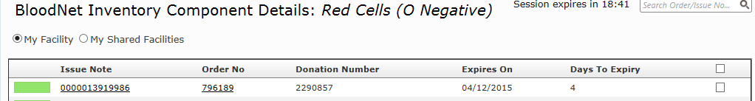
Note: clicking on the issue note or order number of a unit will take you to the relevant issue note or order.

- To auto-generate a Fate episode for multiple units of this type, tick the boxes of the units down the right-hand side.
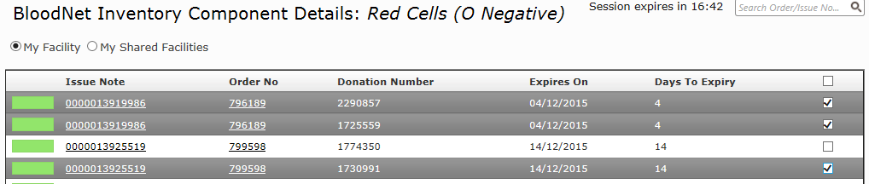
- Once you have selected the units you want to apply Fate to, go to the bottom of the page and select the Fate type from the Next Action drop-down menu. Then click Go.
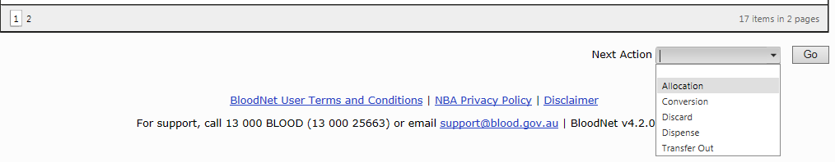
- This will generate a new Fate episode with these unit details pre-populated, the details of which you can then fill out as per usual practice.

